Congregation Transition Process for the
Diocese of Newark

The Bishop’s Office
31 Mulberry Street
Newark, NJ 07102

The Rev. Canon Gregory A. Jacobs
Canon to the Ordinary
Phone: 973-430-9915
Fax: 973-622-6508
gjacobs@dioceseofnewark.org

Almighty and gracious God, be with us and guide us; open our minds and teach us; open our hearts and surround us with your love that we may feel your presence in all our works. Imbue us with wisdom and awareness of your vision as we seek a new rector and spiritual leader. Grant us an adventurous spirit, willing to attempt new tasks and face new ways, ever mindful of the need to listen more to your still, small voice than to our own fancies and desires.

Grant continued grace and commitment to those who have been called to serve as members of the Profile and Search Committees, that they may become faithful companions to each other, to the Vestry and to this Parish.

We ask all this through Jesus Christ, our Lord, who lives and reigns with you and the Holy Spirit, one God, now and forever.

Guidance Prayer for New Ministry

Almighty God, giver of every good gift:
Look graciously on your Church,
and so guide the minds of those
who shall choose a rector for this parish,
that we may receive a faithful pastor,
who will care for your people
and equip us for our ministries;
through Jesus Christ our Lord.
Amen.

BCP, page 818
Reflection on Change During Transition
Revised 07/26/2017

From "Uncommon Gratitude," by Joan Chittister and Rowan Williams
Future is many things at once. It is the vessel into which we pour all our hopes and all our fears. "When all else is lost," Christian Bovee says, "the future still remains." The problem is that future is a panacea for some and a threat to others. It is at the edge of the future that we walk off the side of a cliff into the arms of God.
The spiritual challenge of the future resides in being able to accept it before we know it.
But accepting the future before we know what it is becomes one of the central problems of life. Rather than embrace the unknown, we stumble along from one fear to another. From day to day, intent on going tenderly into the future we want for ourselves, we are inclined to do one of two things: escape the present or cast it in stone.
So we cling and claw our way from day to day,
trying to preserve this, to avoid that, intent on our need to control tomorrow and awash in our uncertainties along the way. Then we begin to see what the future really demands of us. We come to realize that is it not the particulars, the details of time and place and position to which the future
finally takes us that really matter much. No, it isn't so much what happens to us in the future that counts. It is the attitudes we take to it that make all the difference between a future that's full and a future that's frustrating.

Diocesan Mission Statement

Equip Congregations
Empower People
Engage the World
…with the hope and justice of Jesus

A Vision for the Diocese of Newark
We are called to be passionate disciples of Jesus, living in covenant with each other and God, fully equipped, empowered and engaged to undertake God’s mission in the world.
As communities of the faithful, we serve as beacons of hope and justice in our cities, towns and villages, planted and rooted in Northern New Jersey, stretching from the Delaware Water Gap to the Hudson River; from High Point to Route 78.
We are called to be a Covenant People who embrace the richness and beauty of worship that knows no confines other than the Holy, joined together by our fierce love for one another and sharing a Common Prayer.
Drawing on the genius of our Anglican tradition and its incredible resources for movement and language, music and color, symbol and sacrament, we create worship experiences that take peoples’ breath away and mystery that invites transformation.
Knowing that how we worship determines our future, we dare to bring the altar out into the world.
We are called to step out in audacious faith, spiritually formed by a rule of life that resonates with God’s promises, empowering people to become alive and confident in their faith.
Following the example of Christ we joyfully and fearlessly bear witness to God’s story and our own.
Forever seeking new venues in which to proclaim the Gospel, we dare to cross the invisible barriers in our communities and venture into places where we are not expected – indeed, where we are not even welcomed – to be seed throwers, fire starters, hope peddlers, risk takers and dreamers on behalf of the Good News of Jesus Christ.
We are called to enter into the ever flowing stream of God’s justice, emboldened by the Holy Spirit to claim the Gospel, which calls us to stand up and speak up wherever we encounter injustice against both humankind and this earth.
We call upon our own communities and the world to challenge and repent of the false gods that enslave the soul in sin, create social structures of oppression, and tempt us away from fulfilling the spirit of “Ubuntu” – an interconnected world in which “I am because you are.”
Cherishing God’s gift of creation, we strive against the temptations of over-consumption and waste that oppress nature in the name of progress, devastate whole regions, and destroy species.
We dare to speak of God in an increasingly secular world, sharing the wisdom of scripture and telling our stories of God’s grace, love and justice in our lives.
We are called to practice radical hospitality and live into God’s abundant future, celebrating the many talents with which God has endowed each of us.
We seek out and dare to embrace the “Other,” inviting them in, listening to their stories, seeking to be transformed by their presence among us, so that we are all brought deeper into relationship with God.
Embodying an ever-widening circle of concern for the Stranger, the Forgotten and the Outcast, we work to level the playing field, transcending differences, prejudices and misunderstandings.
In faithful response to God’s leading us beyond what we ever thought was possible, we recognize and respond to the need for institutional reformation that will incarnate Christ’s holy mission for our times.

Congregation Transition Process for the Diocese of Newark

TABLE OF CONTENTS

INTRODUCTION 8

TRANSITION MINISTRY ROAD MAP 9

TRANSITION I: SEPARATION AND PLANNING………………………………. 14
Notifying the Bishop’s Office 14
Transition Team 14
Saying Good-bye 15
Provision for Clergy Leadership During the Transition….. ......15

TRANSITION II: SELF STUDY 17
Diocesan Requirements for Conducting a Clergy Search 17
Financial Considerations 17
Search Options 18
Transition Process Timeline 18
The Search Consultant 18
The Search Committee 19
The Vestry’s Charge to the Search Committee 20
The Commissioning of the Search Committee 21
Discernment Retreat 22
Gathering Information for the Parish Profile 22
The Parish Profile 23
Filing the Community Ministry Portfolio for the Parish 24

TRANSITION III: DISCERNMENT 25
Receiving Names 25
Communication and Confidentiality 26
Narrowing the Field of Candidates 26
Visitation to Candidates’ Parishes 27
The Short List 28

TRANSITION IV: THE CALL TO NEW MINISTRY 29
The Vestry’s Discernment with the Candidates 29
Oxford Document Background Check 29
Bishop’s Meeting with Final Candidates 30
Election of Rector 30
The Letter of Agreement 31
Honoring the Search Committee/Celebrating the Interim Ministry 31
PREPARING FOR THE NEW CLERGY 32
Welcome 32
Celebration of New Ministry 32
Conclusion 33

INDEX OF APPENDICES 35

APPENDIX A Position Description Outline 36

APPENDIX B Responsibilities of a Transition Team 47

APPENDIX C On the Ethics of Clergy Transitions and Boundaries 49

APPENDIX D For Clergy: Steps to take before 51

APPENDIX E Exit Checklist for Lay Leaders 53

APPENDIX F A Liturgy of Leave-Taking 57

APPENDIX G To the Laity: Saying Goodbye Well 60

APPENDIX H The Interim Priest
in the Diocese of Newark 61

APPENDIX I The Priest-In-Charge Program
of the Diocese of Newark 64

APPENDIX J Transition Process Timeline 69

APPENDIX K Search Committee Job Description 70

APPENDIX L Sample Budget for Search Process 71

APPENDIX M Sample Charge from the Vestry
to the Search Committee 72

APPENDIX N Sample Liturgy for Commissioning
Search Committee 73

APPENDIX O Parish Profile Outline 74

APPENDIX P Community Ministry Portfolio 75

APPENDIX Q Transition/Interim Communications 82

APPENDIX R Interviewing and Various Sample Questions 83

APPENDIX S Sample Handoff Memo from Search Committee
to Vestry 85

APPENDIX T Grounds Rules for Finalists’ Visits to Parish 87

APPENDIX U Sample Letter of Agreement 88

APPENDIX V Some Thoughts as the Search Committee
Winds Up Its Work 96

APPENDIX W Sample Farewell Liturgy 98

APPENDIX X To Welcome the New Rector 99

APPENDIX Y The Renewal of Ministry
With the Welcoming of a New Rector 100

A GUIDE FOR CONGREGATIONS IN TRANSITION
IN THE DIOCESE OF NEWARK

Introduction

This guide is meant to provide an overview of the transition that takes place in a congregation from the moment when one clergyperson departs and a new clergyperson is installed. The main steps in the process of defining congregational identity and calling new clerical leadership are outlined in the following pages as an aid to vestries, congregations, interim clergy, and search committees in understanding this challenging period. We offer this guide as a “work in progress” that will be amended from time to time based on our growing experience with the ministry of congregational transition.

Throughout this time of discernment and change, the Bishop’s Office supports the congregation by providing periodic consultation and written materials, identifying supply and/or interim clergy, recommending a search consultant to work closely with the self-study and/or search committee, and offering other guidance needed to transition successfully into the next stage of a congregation’s life. Two-way communication between the congregation, clergy, and the Bishop’s Office is an important ingredient in a successful search.

It is an essential part of the mission and responsibility of the Bishop’s Office to assist congregations in transition during their discernment of new ministry and clergy leadership in the Diocese of Newark. To that end, no distinctions are to be made on the basis of gender, race, disability, sexual orientation, age, or marital status.

The implications of this policy for your particular congregation should be addressed in the initial meetings with the representative of this office.

This document is intended as a road map of the transition process. It is not, nor should it be used as, a step-by-step guide. Each congregational situation is unique and should be treated as such. The congregation transition period for purposes of this discussion can be understood in four stages:
1.) Separation and Planning
2.) Self Study: Congregational Self Discernment Process
3.) The Discernment Process for a New Rector
4.) Call to New Ministry

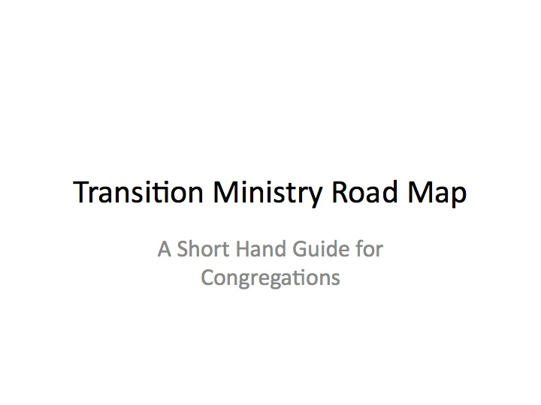

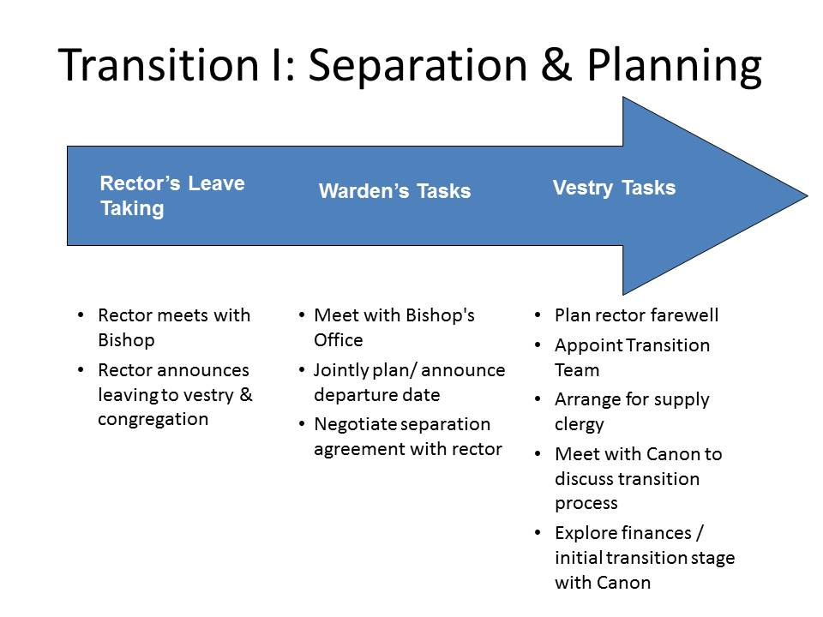
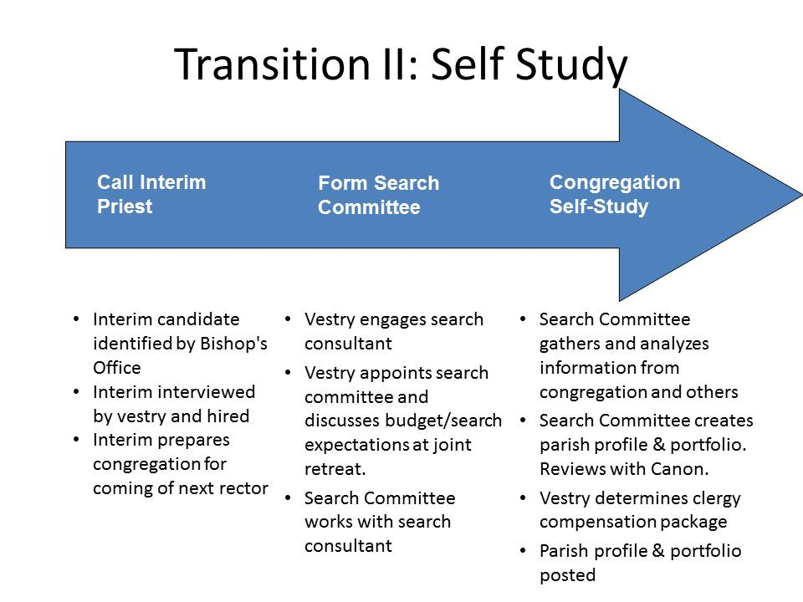
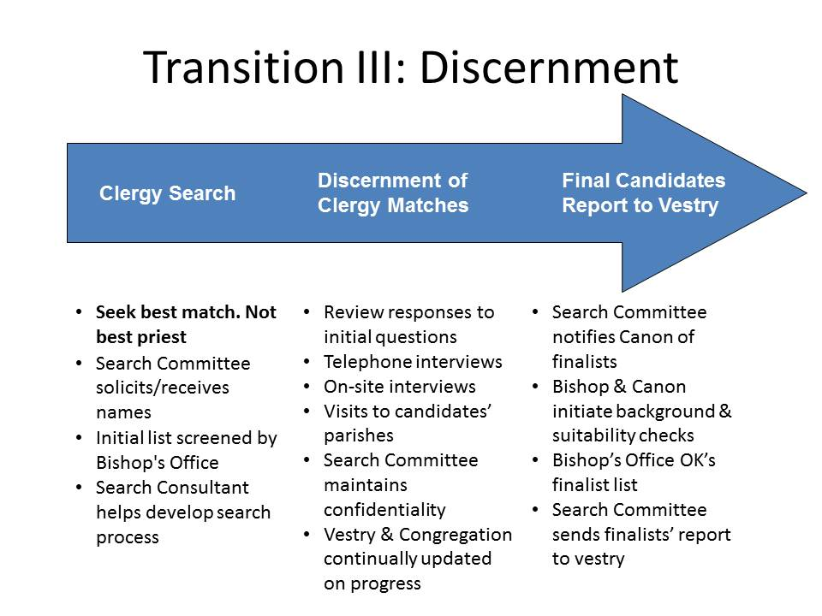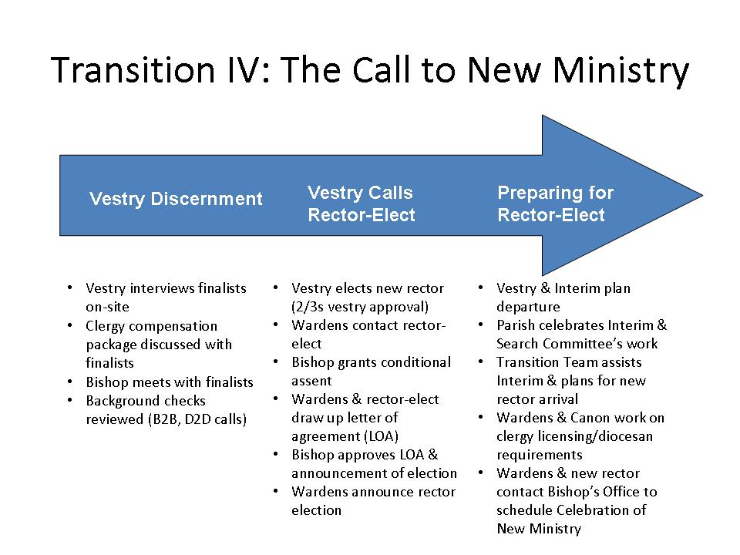

TRANSITION I: Separation and Planning

- Notifying the Bishop’s Office

It is important that the Bishop’s Office be a part of the transition process from the very beginning. The transition process begins when the departing priest meets with the Bishop and they determine together when the announcement to the Vestry and congregation will be made. Generally between 60 – 90 days’ notice should be given. In the case of a retirement, 4 – 6 months may be appropriate. The clergy and wardens will jointly determine how the congregation will be informed of the priest’s departure.

As soon as the priest announces to the wardens his or her intention to leave a congregation, the wardens will make an appointment with the Bishop’s Office to discuss the state of the congregation, as well as their options in the upcoming transition period. At this meeting, the wardens report generally on the congregation and are briefed in turn on what typically lies ahead for a congregation in transition.

The wardens and vestry are the formal and canonical leadership of the congregation during the interim period; as such, they hold the responsibility of choosing a course of action best suited to their particular congregation and situation. With the help of the Bishop’s Office, the wardens must make arrangements for the conduct of worship and pastoral care until an interim priest is appointed. When there is a gap in official ministries, the wardens can secure names of supply clergy to fill in for the short term, on Sundays, and when needed.

After the initial meeting of the wardens with the Bishop’s Office, a visit to the congregation may take the form of a meeting with the vestry and/or the full congregation, normally sometime after the departure of the priest. The Canon or his representative will explain the various search options and share with the vestry (and/or congregation) an overview of the search process as well. Once the vestry submits a “Position Description Outline,” (Appendix A) the Bishop’s Office can advise the vestry on the best search options for its circumstances. The Canon will then discuss what the parish can expect during the interim period so that an interim ministry plan can be made.

- Transition Team

The period immediately following the announcement of the clergy’s departure can be a time of considerable anxiety for a congregation. There is much speculation about “What will happen next?” and “How and when will we get our next priest?” As the canonical leadership during the interim period, the wardens and the vestry will be tasked with the significant responsibility of providing a clergy presence and of maintaining and supporting programs and ministry, a considerable undertaking. It is for that reason that a transition steering team is recommended.

The function of the Transition Team is to point the congregation forward in order to embrace a new vision and possibilities for itself. See: “Responsibilities of a Transition Team” (Appendix B).

- Saying Good-bye

The vestry, congregation, and clergy together should plan and carry out the farewell and celebration of the priest’s ministry, generally before any formal work on the search begins (e.g., before commissioning a search committee). Whether the priest is leaving because of retirement, a call to another parish, or even because of differences with the parish, the elements of the separation process remain the same. Much of the energy of the parish during this time should be devoted to saying “good-bye” in the best possible way.

Clergy and wardens should be mindful that parishioners are often expressing grief and anxiety at the loss of their priest. Therefore, particular attention should be paid to openly discussing appropriate boundaries for pastoral relationships with the congregation before the clergy departs. See, “On the Ethics of Clergy Transitions and Boundaries” (Appendix C). Until the clergy leaves, the primary tasks of the vestry and clergy are to arrange an exit interview, plan the current priest’s departure (including an appropriate farewell service), and provide opportunities for people to say good-bye in a celebratory manner. See, “For Clergy: Steps to take before..” (Appendix D), “Exit Checklist for Lay Leaders” (Appendix E), “A Liturgy of Leave-Taking” (Appendix F), and “To the Laity: Saying Goodbye Well” (Appendix G).

- Provision for Clergy Leadership During the Transition

Pursuant to the canons of the National Church, the Bishop, in conversation with the wardens, appoints a priest to provide clerical leadership. Depending on the particular needs and circumstances of the congregation, the Bishop will appoint either an Interim Priest trained in interim ministry or a Priest-In-Charge to address significant systemic issues, who will serve the parish during the transition period. The appointment is to be confirmed by the Bishop following an interview with the wardens and/or Vestry. See, “The Interim Priest in the Diocese of Newark” (Appendix H) and “The Priest-In-Charge Program of the Diocese of Newark” (Appendix I).
Discernment Not A Corporate Executive Search

Calling new clergy is a process of mutual discernment, engaged in by the congregation and the clergy candidates, in partnership with the Bishop and the Bishop’s Office. This exciting time of seeking the best clergy match (not the best priest) for a congregation should be carried out prayerfully and with faith. Each step of the discernment requires a commitment of time and resources by God’s people deeply rooted in prayer.

TRANSITION II: Self Study

- Diocesan Requirements For Conducting Clergy Discernment

All searches in the Diocese of Newark are undertaken on a non-discriminatory basis. Requests for the elimination of certain categories of people from consideration, based on matters such as race, color, ethnic origin, sex, marital status, sexual orientation, disabilities or age, except as otherwise provided by the canons will not be granted.

The Bishop is eager to have qualified clergy from within the Diocese be given serious consideration by congregations in search. Any priest in the Diocese who meets the qualifications of the position should be given the benefit of at least a phone interview.

- Financial Considerations

It is the responsibility of the congregation to demonstrate that it is financially able to sustain itself and provide the requisite compensation and benefits for clergy for at least a three-year period following the calling of the new clergy.

A congregation, therefore, must meet the following requirements in order to undertake a discernment for clergy:

● Demonstrated ability to pay the full compensation and benefits cost of the rector for the next three years without substantial invasion of investments/endowments

● Audits for the past 2 calendar years performed and filed with the Diocese

● Submission of congregations’ completed parochial report

● Submission of diocesan pledge card and current and regular payment of diocesan pledge (Note: Congregation’s pledge must meet diocesan minimum of 10% or it must provide a plan to reach 10% within two years of the clergy’s hire)

● Congregation has no debt or has a viable debt repayment plan

● Submission of budgets for past 2 years, current year, and three months’ of current financial reports.

Note: The Diocese reserves the right to require additional information in order to adequately assess the financial ability of the congregation to provide the appropriate clergy compensation and benefits.
Search Options
- .
- Traditional search (as outlined in this document).

- An abbreviated search with long/short list:
After the parish completes its self-study, the Bishop’s Office, submits the names of a pre-determined number of candidates (3-5) for the search committee to consider, thus eliminating the steps of sorting through the papers of many prospective candidates. It is the task of the Bishop’s Office in this instance to carry out the extensive groundwork of narrowing the field, and that process, done carefully and sensitively, takes time.

Upon reception of the list, the search committee conducts its work as it would normally, in reviewing and—as required with a short list—interviewing the candidates. If a rector is not called as a result of the discernment process, the congregation may ask for more names or choose one of the other search options.

- Bishop’s Office presents one candidate to the vestry for consideration

- Transition Process Timeline

Depending upon the particular circumstances of each parish, a search may be as brief as nine months or extend to a year-and-a-half or longer. The length of time to complete any given stage depends upon many variables, including the frequency of meetings, willingness of members to work independently and collaboratively, issues that need to be addressed (e.g., financial challenges or resolving conflict), and the length of time needed to develop consensus about the future direction of the congregation and develop the parish profile. A Search Consultant can be useful in setting up a realistic timeline designed to achieve a balance between efficiency and a pace that encourages thoughtful discernment, caution and thoroughness. See, “Transition Process Timeline” (Appendix I).

- The Search Consultant

A list of Search Consultants is maintained by the Bishop’s Office.

A consultant/facilitator experienced in clergy searches is offered to any parish in search. The Search Consultant is engaged by the Vestry but is accountable to the Bishop’s Office for the search process. The Search Consultant meets with members of the Vestry at the beginning of the search process, explaining her/his role in the process, and then working primarily with the members of the Search Committee in guiding them through the search.

The consultant works with the Search Committee to plan and design congregational meetings and focus groups, gather and interpret data, and develop questions and a design for the interview process. The Search Consultant serves as the link with the Bishop’s Office in providing resources and guidance to the congregation during the self-study period and search process.

The Search Consultant can be indispensable in helping the search committee understand some of the more perplexing aspects of a search and in streamlining the process. While every transition is unique, and every Interim and Search Consultant different, it is helpful for the Interim Priest and Search Consultant to work together closely.

E-mail communications concerning the search process between the Interim and the Search Consultant should be copied to the Bishop’s Office, and the Interim and Search Consultant should determine a system for keeping in touch. The greater the communication among all parties, the greater the opportunity for a smooth transition period.

The congregation is responsible for the fees paid to the consultant and should make an arrangement with the consultant for regular payment. If the cost of a consultant will place an undue burden on the congregation, the Wardens are encouraged to contact the Bishop’s Office.

- The Search Committee

Parish members may be invited by the Vestry to submit their names and other parishioners’ names for consideration in the formation of a Search Committee by the Vestry. The composition of the Search Committee should reflect the parish’s diversity, including people of different ages, race, gender, and from various committees and areas of parish life. Please note, this is not the time to recruit all those in the parish with human resources experience to become members of the Search Committee. Rather, the Vestry should attempt to select people with open hearts and minds who will be sensitive to the culture and dreams of the congregation as a whole.

A key member of the Search Committee should be a Chaplain, so consider this position as members submit their names for consideration, The role of the Chaplain is to keep the process Spirit filled and led. Remember, this is a discernment group and having someone to assure the meetings begin and end in prayer, that all voices are heard, that no personal agendas are served and that the will of the community is honored is of utmost importance to your success.

It should go without saying that openly disaffected persons are generally not helpful to a search committee, nor is it appropriate for a member of the parish staff to serve on a search committee.

A good target number for the Search Committee is 8-12 members, and at least one member of the Vestry is encouraged to serve on the Search Committee as a liaison with the Vestry. This serves the purpose of keeping members of each body informed and “in synch”. The wardens may serve ex officio, (i.e., not have a formal vote) and may observe Search Committee meetings when and as they wish. However, we discourage any warden from serving as chair or a voting member of the Search Committee.

If a congregation in search has enough volunteers, it may first want to form a subcommittee charged solely with the self-study portion of the Search (Self-Study subcommittee). In such an instance, it is important that some members of this Self-Study subcommittee also serve on the Search Committee, thereby providing continuity and overlap. See, “Search Committee Job Description” (Appendix K).

- The Vestry’s Charge to the Search Committee

It is important that the Vestry give a charge to the Search Committee determining the scope and extent of the search as well as the budget for the search itself. See, “Sample Budget for Search Process” (Appendix L) and “Sample Charge from the Vestry to the Search Committee”
(Appendix M).

The Vestry also must decide on the range of the compensation and benefit package that it will offer the new priest. Conversation between the Search Committee and the Vestry about the specifics of salary, benefits, and housing situation, is vital from the very outset in order to give an accurate description of the financial position in the parish profile and the listing by the national church Office for Transition Ministry. There are diocesan guidelines to be followed in setting the financial terms, a full description of which is available in the annual Clergy Compensation and Benefits Guidelines obtainable on-line at www.dioceseofnewark.org. Diocesan policy requires that any full-time parochial priest must be paid at least the minimum total clergy compensation as determined by Diocesan Convention.

- The Commissioning of the Search Committee

The Vestry commissions the members of the Search Committee, if they have not already done so in the context of self-study, with the responsibility of identifying the new priest and with the ultimate presentation of his or her name to the Vestry for consideration and approval. The “commissioning” appropriately may take place during Sunday worship and signals liturgically the significant responsibility and role Search Committee members are assuming in the life of the congregation. See, “Sample Liturgy for Commissioning Search Committee” (Appendix N).

TRANSITION II: Self-Study/Creating the Parish Profile

- Discernment Retreat

A discernment retreat for the Vestry and Profile/Search Committee is recommended as a fruitful undertaking during a search. The retreat encourages the participating members of both the Vestry and Search Committee to view their work as a spiritual journey, over the course of which decisions are made through prayer and reflection. The retreat may be led by the Interim Priest with the Search Consultant, and/or an outside facilitator recommended by the Bishop’s Office.

A Parish Search Prayer may also be developed for the whole congregation that invites a spirit of thoughtfulness, collaboration, and faith-building. Many committees ask that the Interim Priest or one member of the committee act as their “chaplain” so as to keep them spiritually grounded by beginning and ending meetings with prayer and encouraging the use of the Parish Search Prayer by the congregation throughout the transition period.

- Gathering Information for the Parish Profile

In its first phase, the Self-Study subcommittee (or the Search Committee) will take an in-depth look at the parish—its history, its identity, its mission and goals. In a real sense, the parish first searches for itself before looking for a pastor: What kind of community is it? What kind of parish has it been in the past? What new shape is God calling it to become? How can the parish realize its vision of itself in the future and, ideally, under what kind of leadership?

The Self-Study is a kind of discernment of what the faith community is at its best, of the congregation as the Body of Christ in a special configuration. It is at best an imagining of what God’s dreams are for the community of the faithful.
The Search Consultant and the Interim Priest give counsel to the subcommittee throughout this important stage. The Self-Study can take many forms, inviting the whole parish to participate by:

- Holding an Appreciative Inquiry Workshop
- Conducting informational interviews within the congregation, in the community and with other churches
- Using questionnaires and surveys to canvass parish opinion
- Delving into archives for historical material
- Gaining demographic information on the area in which the parish is located
- Reviewing anecdotal history, written and verbal, as supplied by older members, and
- Envisioning the future in focus groups by imaginative and creative exercises.

The use of surveys as the only tool for self study/assessment by the Search Committee is not recommended.

A variety of resources relating to congregation self-study are available from the Bishop’s Office.

- The Parish Profile

Following the period of self-study, the Search Committee will prepare a parish profile. This product, a “story” of the parish may range from a one-page summary to a more elaborate and illustrated booklet. For cost reasons, we strongly urge the parish to consider creating a tri-fold or similar size profile that briefly describes the personality, mission and ministry of the congregation, but focuses on the uniqueness of the parish and the passions and gifts for ministry it is seeking in its next priest. See, “Parish Profile Outline” (Appendix O). Such a brochure can then be sent to all inquiring candidates. A more-detailed parish profile should be made available via the parish’s website.

Equally important, is to ensure that up-to-date and accurate congregation financial information, as well as the elements of the clergy compensation/benefits package, be made available for inclusion in the parish profile.

It is the expectation of the Bishop’s Office that the written profile or “story” of the parish, first be reviewed by that Office before it goes to final publication. Many parishes choose to post their profile on their own web site, and the final copy once received by the Bishop’s Office can be linked via the Diocesan Website as well. Examples of parish profiles from past searches are available from the Bishop’s Office.

The description of the congregation contained in the parish profile is meant to be a representation of the community of faith on which the wardens, vestry, search committee, and congregation agree. In the spirit of discernment, reflection, collaboration, and self-definition, a congregation “grounds itself” in its own reality rather than delineating the projected abilities of a new priest. The more honest and transparent a congregation is in telling its story, the greater chance of attracting appropriate candidates and the less opportunity there is for disillusionment following the call. If there is to be a second separate committee conducting the next phase of the search, it is appropriate to have the two groups come together and officially transition from the Self-Study Committee to the Search Committee.

- Filing the Community Ministry Portfolio for the Parish

At the end of the Self-Study phase, the Self-Study or Search Committee, together with the Search Consultant, must complete a “Community Ministry Portfolio” published by the Office for Transition Ministry of the Episcopal Church (OTM) in New York which is provided by the Bishop’s Office. The Community Ministry Portfolio should be carefully prepared, verifying that all information is accurate and consistent with the Parish Profile. When complete, the Community Ministry Portfolio is sent for review and subsequent posting by the Bishop’s Office. See, “Community Ministry Portfolio [Worksheet]” (Appendix P).

TRANSITION III: Discernment

At this point the congregation is said to be “Receiving Names” and begins accepting applications from interested clergy. The Bishop’s Office posts the Community Ministry Portfolio on the Office for Transition Ministry website www.otmportfolio.org.

The Bishop’s Office will also post a Summary Profile on the “Transition Ministry Newsletter website,” in order for the parish to be listed in this major national publication read by many clergy in search.

A listing also appears on the diocesan web site with links to the portfolio and profile. Search Committees should check with the Bishop’s Office in advance to insure that precise deadlines are met in order for notices to appear in a timely fashion. Much of this information can be provided to the Bishop’s Office even when the parish is still in Self-Study.

- Receiving Names

The Search Committee normally receives names from the following sources:

- Candidates themselves, who submit their applications directly to the congregation
- Candidates recommended by parishioners
- Candidates recommended by the Office of the Bishop

- Communication and Confidentiality

Communication with the congregation is essential. While the conduct of the deliberations and the names of nominees must remain confidential, it is important to communicate on a regular basis the progress of the process – even if that means simply informing the congregation that the search committee will not be meeting for several weeks.

Confidentiality is not secrecy. Parishioners must be assured that the transition period is being well managed and that progress, however seemingly invisible, is being made. Otherwise, the members may complain that “Nothing is happening.” The chair of the search committee should therefore give oral updates during announcements or parish functions. If new members are elected to the Vestry in the course of the search process, it is important to bring them up to date on the status of the process.

Members of the search committee should understand how important it is to maintain confidentiality as often prospective candidates have not yet informed their own congregations that they may be in search. For search committee members to do otherwise is to risk great damage, both to the candidates and to their congregations. It is very harmful to the integrity of the process if a search committee member “leaks” information to anyone in the congregation, including a spouse or other family member during the course of the search process. Equally important is to provide for the security of search committee files throughout the process. See, “Transition/Interim Communications” (Appendix Q).

- Narrowing the Field of Candidates

Once the period for receiving names has passed, (generally 6-8 weeks) the search committee’s task is now to sort through the candidates’ materials efficiently and yet not arbitrarily, to the end of narrowing the field to fewer and fewer applications and to create a “long list” of 7 to 10 serious candidates. Eliminating candidates on the basis of the clergy portfolio alone is not a recommended practice unless it is clear from a close reading that the candidate is unsuitable.

At the outset, the supporting materials, such as the candidates’ resumes, clergy portfolios, and their response to short (no more than 2), well-written questions crafted by the committee members, help acquaint them with the potential priest and the gifts for ministry that he/she will offer to the congregation. A search consultant’s guidance is beneficial to following a process that is both thorough and faithful. The Search Committee Chair should provide periodic updates concerning the Committee’s work.

Once the search committee has conducted preliminary interview and identified a list of 5-7 candidates, that list should be submitted to the Bishop’s Office along with the names and the dioceses in which the candidates are both canonically resident and are presently exercising their ministry. By reviewing the list of clergy being considered, and conducting a preliminary “red flag” check, the Bishop’s Office is alerted to any issues that might prevent a priest from being considered for deployment.

At the same time there may be candidates who have significant gifts that are not apparent “on paper”, and this information can be shared with the search committee where appropriate. The Bishop’s Office will engage in conversation with the search committee throughout the process and reserves the right to add names at any time, particularly when the slate does not appear to contain candidates with a good “ministry fit” or reflect the Diocesan commitment to diversity.

The goal is to ensure the richest possible pool of potential candidates for the search committee to consider. At the same time, the search committee is proceeding to screen its list of candidates by various methods, including, soliciting taped and/or written sermons for the committee to hear or read, reviewing references, and conducting telephone interviews.

Once the list is reduced to 5–7 names, search committee members should plan to invite the candidates to meet with them at the parish or at the home of a search committee member to introduce the candidate to the parish environment and to get to know the candidate. See, “Interviewing and Various Sample Questions” (Appendix R). This would also be the time to review the Parish’s financial status with the candidates by sharing your most recent financial records and by reviewing the parish’s income streams (e.g. schools, long-term rentals, etc.). It is important for the candidates to have a clear picture of the church’s financial stability at this time in the process. Further, the detailed clergy compensation package should also be shared and discussed. The search consultant can compile a suggested protocol for the candidate visit.

- Visitation to Candidates’ Parishes

Search committee members may also plan to attend worship services in the candidates’ own parishes or make similar arrangements with congregations to see/hear the candidate celebrate worship, as part of their discernment following their face-to-face meeting with candidates. The number of parish visits is usually driven by time and cost – (i.e. if candidates are all serving in local parishes it is much easier to plan a visit). Committee members should be discreet when making such visits, and the “calling committee” should not include more than 3-4 persons since the parish is often not aware that its priest is engaged in an active search.

Throughout the screening process, the search committee as a courtesy must notify in writing those candidates whose names are no longer under consideration. It is important to remember that clergy in search often put their lives “on hold” or have to make important decisions with respect to their lives and/or their families as their own search processes unfold. Not informing them in a timely manner about the progress of the search not only shows a lack of consideration for the candidates, but also reflects poorly on both the congregation and the Diocese.

- The Short List

When the search committee has arrived at a final list (usually 2-4 names) of final candidates, those names with full private addresses should be reported to the Bishop’s Office so that a full background check on each candidate may be initiated. The Bishop and the Canon to the Ordinary, acting as transition ministry officer, will also contact their respective counterparts in the dioceses in which the finalists have practiced significant parts of their ministry.

TRANSITION IV: The Call to New Ministry  

- The Vestry’s Discernment with the Candidates

Because the vestry has not taken part in the formal discernment process to this point, a retreat should be planned as part of the process of submitting the names of the finalists to the vestry. Both vestry and search committee should appreciate this as a sacred moment — a spiritual handing over of the search committee's discernment to the vestry which now must undertake its own separate discernment. Here is an opportunity for the search committee to give voice to its hopes and fears as the process moves forward and for the vestry to hear the expectation that its discernment be deliberate, Spirit-led, and grounded in prayer. The presence of a chaplain is particularly important in helping all present recognize that the vestry will not be engaging in a "business decision", but in a spiritual reflection and meditation, seeking to know who God is calling to be the next clergy companion for this congregation. Time may be taken during the retreat led by the search consultant to review the vestry's discernment process, clarify roles and responsibilities, prepare interview questions, and perhaps role-play the actual meetings with the finalists.

Once the search committee comes to consensus on whom it wishes to recommend as the next rector of the congregation, the name (or names) is presented to the vestry for consideration and a vote of approval. Depending on the process to which the vestry has earlier agreed through its charge to the search committee, exposure to the candidate(s) by the Vestry varies. Normally, the search committee will present a final report to the vestry outlining how this person’s gifts for ministry match the parish profile goals and responsibilities. See, “Sample Handoff Memo From Search Committee to Vestry” (Appendix S).

Vestries should meet the finalist(s) informally at a social occasion, coupled with an interview and tour of the area. The goal is for the vestry to get some sense of this person’s call and desire to be the next rector, not to duplicate the efforts of the search committee. The final interviews of candidates should include arranging for an interview with the Bishop during their visit.

By reviewing the parish profile and community ministry portfolio, candidates are acquainted generally with the financial terms the parish may offer, but during the final interview stages discussion of the financial package and the general financial status of the parish must take place. Candidates coming from outside the diocese should particularly be made aware of the high cost of living (especially housing) in New Jersey. See, “Ground Rules for Finalists’ Visits to Parish” (Appendix T).

- Oxford Document Background Check

Background checks concerning sexual misconduct and criminal offenses are required for all clergy at any point of transition (pre-ordination, licensing, and employment) in the Diocese of Newark. All finalists must have a complete background check. This differs from the preliminary background screening performed by the Bishop’s Office, which simply insures that candidates are priests in good standing.

The time needed to complete a formal background check may be as long as 6 weeks. It is important for the search committee and vestry to understand that a background check cannot be initiated until the Oxford Document Management Company has received the signed forms from both the candidate and the Bishops Office. The names of the finalists should be forwarded to the Bishop’s Office as soon as possible so that the Oxford Document check can be initiated at the earliest possible moment.

The congregation is responsible for the cost of background checks, which vary depending on whether the candidate has previously completed a background check for the Diocese of Newark or for Province II. In such cases, the results may be transferred or updated, for a cost of approximately $45.

A note about Background Check fees
Two types of background checks will be requested.
- “Referencing” (usually $155)
- “Public Records” (usually $110 but this amount can vary, depending on the number of states and counties lived in)
Depending upon billing cycles, you may receive two invoices.

- Bishop’s Meeting with Final Candidates

At this stage, the search committee chair or wardens will contact the Bishop’s Office to schedule a meeting between each of the final candidates and the Bishop. The purpose of this meeting is to acquaint the candidate with the Diocese of Newark and to establish a relationship with the Bishop of the Diocese. This is normally done during the candidate’s visit to the parish for the personal interview with the vestry. Please be mindful that the Bishop’s schedule is often heavily booked. Therefore, requests for appointments should be made at least a month in advance of the candidates’ visits.

Following the Bishop’s meeting and the vestry’s interview of the finalists, the Bishop’s Office reserves the right to meet with the vestry prior to its discernment in order to share impressions of the candidates, as well as information learned from the Bishop’s and the Canon’s conversations with their counterparts concerning the candidates.

- Election of the Rector

After the Vestry’s meeting with the Bishop’s Office, the vestry must hold a formal vote for the election of the rector. Again, time should be set aside for prayerful discernment and reflection prior to taking the formal vote. Please note that New Jersey state statutes require at least a 2/3s vestry majority for the election of the rector. The Bishop must be notified following the vote in order to give the response required by the national canons. Please note no call may be issued or announced without the express consent of the Bishop.

Upon receiving the Bishop’s approval, a call is then issued, a privilege traditionally enjoyed by the wardens. A call should be issued in writing, following a telephone call to the rector-elect. Announcement of the call needs to be scheduled to everyone’s convenience—especially the candidate who must out of consideration inform the current congregation that he or she is leaving.

- The Letter of Agreement

Details regarding the rector’s terms of employment (amount of cash stipend, housing arrangements or allowance, moving expenses, benefits, and description of responsibilities) are negotiated with the vestry and/or wardens, and are later spelled out in a formal Letter of Agreement that is concluded between the parish and the clergy person who has been called.

The Letter of Agreement is drawn up for signing by the new rector and the vestry, and then sent to the Bishop, finally, for review and signature. So long as there is general agreement on the terms, and approval by the Bishop, there is no requirement that the Letter be formally signed by the Bishop prior to the announcement of the new call. Its signing completes the process and concludes it formally. Assistance from the Bishop’s Office, including a template of a Letter of Agreement, is available. The template is also available in this manual (“Sample Letter of Agreement”, Appendix U) and on the Diocesan website.

- Honoring the Search Committee/Celebrating the Interim

The Search Committee is encouraged to finish its work by writing an evaluation of the search process and filing its report with the Bishop’s Office. Materials left over from the search should be disposed of in an orderly fashion since much of it is confidential in nature and inappropriate for parish archives. See, “Some Thoughts as the Search Committee Winds Up Its Work” (Appendix V). Feedback from the search consultant on the experience of the search process and any aspect of it is usually welcomed by the search committee. Successful completion of the work of the search committee is also cause for celebration, either in the context of the congregation or simply by the committee itself.

Recognition of the ministry of the Interim Priest and bidding him or her good-bye merits the attention of the congregation at the end of the transition period. See, Appendix W, “Sample Farewell Liturgy.” The Bishop’s Office also encourages an exit interview with the departing Interim Priest. 

Preparing For the New Clergy

- Welcome

When the call has been issued and accepted, it is appropriate for the vestry to ask the Transition Team to serve as a committee of welcome. They will assist in the beginning of the new ministry. The Transition Team might plan coffee and dessert for small groups to assist the new rector in meeting people, provide groceries for the first week, see to it that the rector’s office is ready to be occupied, or provide maps and contact information for example. See, “To Welcome the New Rector” (Appendix X). It is also important to notify the district convener(s) of the respective district so that he or she may welcome the new rector as well.

Usually, the new rector is already employed in another parish. He or she must allow time for responsible departure, which includes setting a date in conjunction with the bishop and vestry, for saying “good-byes”, perhaps for a bit of vacation, and for packing and moving before the new ministry begins. It is often at least two months after acceptance of the call before the new rector is in place and not uncommon for a longer period of time to be required.

- Celebration of New Ministry

It is customary after the arrival and settling in of the new rector for the parish to schedule a Celebration of a New Ministry. The rite found on page 559 of the Book of Common Prayer is used by many parishes. Now available is “The Renewal of Ministry with the Welcoming of a New Rector or Other Pastor” found in Enriching Our Worship 4 (Appendix Y). The Bishop will make every effort to officiate and preach at this service. If, however, given his schedule, this is not possible, the clergy district convener may be invited to act as the celebrant on behalf of the Bishop.

Please remember to invite the clergy of the district to participate as appropriate. It is a good way for the new rector to meet his/her fellow colleagues in ministry as well. We encourage also the invitation of those people who have been helpful throughout this process, including the search consultant, the Interim Priest, and any clergy who have served the parish during the interim period. This liturgy marks the official end of the transition period.

- Conclusion

The new rector is in place, at last. This is in itself, a significant accomplishment but hopefully, it is not the only benefit a parish has received from its involvement in the interim process. Much of a parish’s involvement and benefit depends upon the extent and enthusiasm of participation, and that, in turn depends upon the leadership of wardens and vestry. Many parishes report discovery of exciting new dimensions in their ministry, an increased sense of identity and purpose, newly identified resources in lay leadership, or a new recognition of its relationship with the Bishop and the wider church. May all these blessings and many more be yours as you come to the close of this important time.

Transition Manual Appendix Documents

A collection of resources for use during the period of transition

INDEX OF APPENDICES

APPENDIX A Position Description Outline.................................................... . 36
APPENDIX B Responsibilities of a Transition Team .................................... ..45
APPENDIX C On the Ethics of Clergy Transitions and Boundaries................ 47
APPENDIX D For Clergy: Steps to take before 49
APPENDIX E Exit Checklist for Lay Leaders 51
APPENDIX F A Liturgy of Leave-Taking 55
APPENDIX G To the Laity: Saying Goodbye Well 58
APPENDIX H The Interim Priest in the Diocese of Newark 59
APPENDIX I The Priest-In-Charge Program of the Diocese of Newark 62
APPENDIX J Transition Process Timeline 67
APPENDIX K Search Committee Job Description 68
APPENDIX L Sample Budget for Search Process 69
APPENDIX M Sample Charge from the Vestry to the Search
Committee..................................................................................70
APPENDIX N Sample Liturgy for Commissioning Search Committee 71
APPENDIX O Parish Profile Outline 72
APPENDIX P Community Ministry Portfolio 73
APPENDIX Q Transition/Interim Communications 80
APPENDIX R Interviewing and Various Sample Questions 81
APPENDIX S Sample Handoff Memo from Search Committee to Vestry 83
APPENDIX T Grounds Rules for Finalists’ Visits to Parish 85
APPENDIX U Sample Letter of Agreement 86
APPENDIX V Some Thoughts as the Search Committee
Winds Up Its Work 94
APPENDIX W Sample Farewell Liturgy 96
APPENDIX X To Welcome the New Rector 97
APPENDIX Y The Renewal of Ministry
with the Welcoming of a New Rector 98

Position Description Outline
The Episcopal Diocese of Newark
Appendix A

Once completed, this clergy position will be posted on our diocesan website with a link to this document.

Date Submitted________________________

GENERAL INFORMATION

Congregation Name ____________________________________________________

Street Address _________________________________________________________

City_____________________________ New Jersey Zip___________________

Telephone: Area Code ______ / ______________ Fax:_______/________________

E-mail address: _________________________________________________________

Website: _______________________________________________________________

Social Media (Facebook, Twiiter, etc.)_________________________________________

PARISH LIFE

Worship

The following group of questions is intended to give us a feel for your congregation’s weekly worship experience.
- What is the time of your Sunday service(s)?____________
- How many people can you comfortably seat in your church?_________
- What was your Average Sunday Attendance in 2016? _____ For Easter?_____ For Christmas Eve?______
- How do you provide for music in worship? (check all appropriate answers) Organ ____; Piano _____; Recorded music ____; Paid organist (pianist) _____; Volunteer organist (pianist)___ Contemporary music provided by ____________________________
- Do you have a choir? (check the appropriate answer): Every Sunday ____;Special occasions only _____; No choir _____; Other music leaders ____; No music leaders ____
- Who usually assists the priest in the service? (check all appropriate answers) Associate Priest___ Deacon _____; Lay Eucharistic Ministers _____; Acolytes ______.
- Are your acolytes: Adults? ____; Young People?____; Some of Each _____
- Is your church heated comfortably during the winter months? Yes ___ No ___. Is it air conditioned in the summer? Yes ___ No ___
- Do Sunday school children join the congregation for the Eucharist? Yes ____ No ____.
- Are services conducted in English? __ Spanish? __ Korean?__ Another language? Which one? ___________ (Check all appropriate answers).
- Does your sanctuary show any structural problems, such as leaky roof, water damage; broken or missing windows, sloping floor, stress fractures in walls; falling plaster? Yes ___ No ____
- If you answered “Yes,” describe those building problems here:
Nurture

The following group of questions is intended to acquaint us with your Christian education, membership development, stewardship and leadership development programs
- Do you have a Sunday school for young people? Yes ___ No ___.
- What is the average Sunday attendance of your church school? ________
- How many adult teachers of Sunday School do you have ? ______
- Are Sunday School pupils grouped by age in separate classes? ______________
- Do you have a youth choir? Yes ____ No ____ If Yes, how many? _______
- Do you have a teen program? Yes ___ No ____ If Yes, how many? _______
- If “Yes”, how many adults work with your teens? ______
- Do you have an ECW? ____ Men’s club? ____ Altar guild? ____ or Any other group or guild ____ (check the appropriate answers)
- Have you had a confirmation class in the past 6 years? Yes ____ No ____
- Do you have a regular adult education program? Yes ___ No ___. If Yes, please describe:

  - If “Yes,” many times did the program meet during the past year (check the appropriate answer)? Less than 5 ___ 5 to 10 ___ More than 10 ____
  - How many adult persons led your adult education programs? ______
- Do you have a special Lenten program? Yes ___ No ___. Give a brief description of your program:

- In the past year, did anyone from your church (clergy or laity) attend any educational programs, leadership conferences, congregational development programs offered by the diocese or another organization? Yes ___ No ___
  - If “Yes,” how many individuals attended?___
  - If “Yes,” which programs did they attend? (Please list them here)

Stewardship
- Do you have a stewardship committee? Yes ___ No ___. If yes, how many members? ____
- In the past year, was any of the following part of the stewardship program?
  - An all member stewardship canvas: Yes ___ No ___
  - Small group meetings Yes ___ No ___
  - Letters to the congregation Yes ___ No ___
  - Pledge cards Yes ___ No ___;
  - Stewardship articles in the newsletter or Sunday bulletin Yes ___ No ___
  - Personal testimonials about stewardship Yes ___ No ___.
- Are new members asked to pledge in their first year? Yes ___ No ___
- Is proportionate giving an important part of your stewardship program? Yes ___ No ___
- Did you begin, conduct, or complete a capital campaign in the past two years? Yes ___; No ___. If yes, what was the purpose or goal of the campaign?_______________________________________
- Did you use a professional firm to assist with the campaign? Yes ____ No ____

Welcoming & Hospitality
- Do you have a membership committee? Yes ___ No ___
- Are greeters assigned to welcome newcomers at Sunday services? Yes ___ No ___
- Do you have a regular coffee hour after Sunday services? Yes ___ No ___
- Are greeters designated to introduce newcomers during coffee hour? Yes ___ No ____
- Are visitors added to your church mailing list? Yes ____ No ____
- Do you hold dinners or other fellowship events at your church? Yes ___ No ___
  - If yes, what kind? ________________________________________
  - How many are you able to seat comfortably in your location for dinner?
    - 1-25 ___ 25-60 ___ More than 60 ___
- Did anyone join a committee or take part in a ministry for the first time in your church?
Yes____ No____ If Yes, how many? _______
- Do any teens or young adults (ages 18-30) serve on your vestry or in some leadership role?
Yes __ No___ If “Yes”, how many? ______

Outreach
- Which of the following outreach programs occur at your church? (Check all appropriate answers) Soup kitchen ___; Food pantry ___; Deliver food and clothing to the homeless ___; Thrift Shop ____; Organized visits to hospitals, nursing homes or shut-ins ___; Fund raising for charities ___; English as a second language classes ____; Day care (or after school care) ___; After School programs ___; Seniors programs___; Other __ (please list ) ________________________________________________________________
- Please list the programs you support with volunteers, but occur off your premises:________________________________________________________
- How many parishioners contribute their time regularly to outreach done through or at your church? (check the appropriate answer) Less than 10 ___; 10 to 20 __; More than 20 ___.
- Does the congregation expect to start any new outreach ministries during this year? Yes __No ___ Please describe:

Buildings and Property

What is the current state of your physical plant?

What significant repairs do you anticipate needing in the next three years?

Do you presently rent any part of your building? If “Yes”, do you have a lease agreement? What rent do you currently receive? Does the rent include payment for utilities and property taxes?

Our Congregation’s Goals

Define the four most important ministry/mission goals your congregation hopes to accomplish in the next two or three years. Make sure they are SMART goals: Specific, Measurable, Agreed upon, Realistic, Time framed.

1.____________________________________________________________________

2.____________________________________________________________________

3.____________________________________________________________________

4.____________________________________________________________________

How did you come up with these goals? (Check all that apply)
- Survey ___
- Worked with consultant ___
- Community meeting ___
- Focus (Small) Group ___
- Vestry ___
- Committee ____
- Other ____ (Please describe)

Does your congregation have a ministry plan? Yes__ No___

A mission statement? Yes __ No__ If so, please either or both.
What are the strengths of this congregation?

What are the challenges that this congregation faces?

Clergy Ministry Skill Areas & Responsibilities

Using the following list of 16 Ministry Skill Areas, identify and rank the four most important areas and then list the duties the priest will perform to fulfill that responsibility.

1. Administration: Ability to manage the affairs of the congregation, diocese, or other institution, including programs, organizations, finances, etc.

2. Christian Education: Ability to lead in the design and implementation of comprehensive programs of Christian Education.

______ 3. Church Growth/Development: Ability to reshape or restart existing congregations or to plant new congregations.

_____ _4. Ecumenism: Ability in programs sponsored inter-denominationally or jointly by a number of churches.

5. Evangelism: Ability to train and lead persons to proclaim by word and action the Gospel of Jesus Christ, and to invite others into Christian fellowship.

6. Liturgics: Ability to plan and conduct liturgical services of corporate worship.

7. Music Ministry: Ability to support congregational ministry through music, e.g. lead, inspire, perform, compose, train, coordinate.

8. Outreach Ministry: Ability to equip and serve the community of faith in ministry to persons in need within and beyond the congregation.

9. Pastoral Care: Ability to care for people so that they are nurtured and equipped for growth within the community of faith.

10. Preaching: Ability to preach with clarity and to make the Gospel relevant in people’s lives.

11. Social/Community Ministry: Ability to enable persons within the congregations to become aware of and participate in community concerns.

12. Spiritual Guidance: Ability to lead and encourage others in the formation and development of a deeper spiritual life.

13. Stewardship: Ability to lead in the development and use of individual and congregational resources.

14. Teaching: Ability to help persons of all ages understand and live the Christian Faith.

15. Home Visitation: Ability to provide regular pastoral care through visiting church members in their homes.

______ 16. Youth Work: Ability to inspire youth and incorporate them onto the full life and ministry of the Church.

Clergy Ministry List of Duties

Here is an example:
Skill Area: Pastoral Care

Duties
a. Take communion to the homebound at Christmas and Easter.
b. Visit members in the local hospital, nursing homes, and assisted living facilities once a week.
c. Develop program to train a lay caring/calling ministry
d. Be available for pastoral emergencies, wedding, and funerals.

1. Skill Area:__________________________________________________________

Duties
a._________________________________________________________

b. ________________________________________________________

c. ________________________________________________________

d. ________________________________________________________

2. Skill Area:___________________________________________________________

Duties
a._________________________________________________________

b._________________________________________________________

c._________________________________________________________

d._________________________________________________________

3. Skill Area:___________________________________________________________

Duties
a._________________________________________________________

b._________________________________________________________

c._________________________________________________________

d._________________________________________________________

4. Skill Area:____________________________________________________________

Duties
a._________________________________________________________

b._________________________________________________________

c._________________________________________________________

d._________________________________________________________

Leadership Style
Briefly describe the leadership style of your next priest that you believe would be the most effective for this congregation.

CLERGY POSITION DESCRIPTION

We are seeking (please check one):

____Interim Priest

____Priest-in-Charge

____Rector

____Priest-in-Residence (Sundays+10-15 hours/week)

____Supply Clergy (Sunday)

The Clergy will be employed in a (please check one):

_____ Full time position

_____ Half time position (25 hours plus full benefits).

_____ Part time position (up to 25 hours, offering some additional benefits).
- How many hours?
- Specify what benefits will be offered

_____ Long term supply (Sundays only)

_____ Other (Please specify)

Note: You will need to develop a letter of agreement after you have called a priest, notified the Bishop, and received the Bishop’s consent.

Proposed Compensation for New Clergy

Please see “Understanding Clergy Compensation” on our diocesan website for guidance.

Starting minimum cash stipend _____________

Housing
Housing allowance (amount budgeted) or _____________
Housing is provided ____

Utilities (amount budgeted or spent last year) _____________

FICA Reimbursement (0.0765 of cash + housing + utilities) _____________

Housing Equity (if Housing provided) _____________

Church Pension Assessment _____________
(18% of total cash stipend +housing+ housing equity+ utilities)

Travel reimbursement (amount budgeted) _____________

Business expenses (amount budgeted) _____________

Health insurance _____________

Continuing education (amount budgeted) _____________

Vacation

How many days a year? _____________

How many Sundays? _____________

Time off after Christmas and Easter? _____________

FINANCIAL INFORMATION

Note: Before any congregation begins the transition ministry process, it must first provide the following:

- The prior 2 (two) years’ audited financials
- The previous year’s budget and actual results
- The current year’s budget and the financial statements for the year-to-date period compared with the current budget.

The congregation must also demonstrate that its current diocesan pledge is at least 10% of its normal operating income or that it will submit a plan to reach this goal in 2 (two) years.

Contact Information (Who may applicants contact for further information?)

Name _________________________________________________________________

Street Address _________________________________________________________

City___________________________________________________________________

State ___________________________ Zip Code _____________________________

Home phone: Area Code _______/___________ Cell ______/__________________

Fax __________________________________________________________________

Email address __________________________________________________________

I prefer to be contacted by: ___ phone ____cell phone
___ email ____mail

NARRATIVE FOR POSITION DESCRIPTION
[Please complete this section if you are seeking a rector or priest-in-charge]

- Describe a moment in your worshipping community’s recent ministry which you recognize as one of success and fulfillment.

- Describe your congregation’s liturgical style & practice. If your community provides more than one type of worship service, please describe all:

- How do you practice incorporating others in your ministries?

- Describe your worshipping community’s involvement in either the wider Church, the Diocese, or locally.

- How do you engage in pastoral care for those beyond your worshipping community?

- Describe your congregation’s stewardship program and how it shapes the life of your community?.

- How are you preparing yourselves for the Church of the future?

- Do you have a ministry to children, youth, and/or young adults? If so please describe what you do.

- As a worshipping community, how do you care for your spiritual, emotional, and physical well-being?

What is your congregation’s experience with conflict? And how have you addressed it?

Please provide words describing the gifts and skills essential to the future leaders of your worshipping community.

Additional Portfolio Resources (Optional)

To assist you in finding candidates for your clergy position, you may wish to attach samples of any of the following:

- Transition Ministry Worshipping Community Portfolio

- Parish history

- By-laws

- Current parochial reports

- Current and last year’s budgets

- Executive Insite (demographic study)

- Attendance, Giving, Membership 10 Year Trend Graph

- Sample worship bulletins

- Newsletters published during the last calendar year

- List of parish organizations

- List of parish leadership with contact information

- Annual meeting reports

- Vestry minutes for the last six months

03/29/16

Appendix B

Responsibilities of Transition Team

The Transition Team, created by the Vestry at the time of the announcement of a clergy’s upcoming departure, particularly when there may be a longer than average period of time between announcement and departure, serves primarily to oversee the over-all health of the clergy and parish in the interest of a life-giving and positive transition time. The Transition Team should be made up of about 4 – 8 members and meet as needed with greater time and attention often focused during the time of leave-taking and again for the welcoming of the new Rector.

The time of transition is an especially important time in the life of a parish, and much of the team’s efforts should be centered on being the “eyes and ears” of the vestry and wardens. Recognizing that this is a time of high anxiety and much uncertainty, the transition team should act as that calm reassuring voice that combines empathetic listening with patient understanding. It should also have a sense of what issues need to be addressed and then channeling that vital information back to the vestry. The expectation is that the team’s members themselves may not do all of these tasks, but will find people to take on various responsibilities. One member of this Team should be on or attend vestry meetings to report on their work.

The team’s specific tasks might include:

● Provide support for whatever Clergy may be present. This means the departing Rector, the interim, the new Rector and their families.

-  
● Coordinate celebrations and thanksgivings for the ministry of the departing Rector including the final service.

-  
● Monitor the transition process which means interacting regularly with Clergy, Vestry, and parishioners to listen to thoughts and concerns about the transition period.

● Enhance and enable communication throughout the transition time by supporting and sponsoring pot-luck dinners, picnics etc. that encourage conversation.

● Serve as “spotters”, noting parishioners who don’t seem to be around as often and making a conscious effort at reaching out to those on the margins or those who have become disenfranchised.

● Assist the vestry in gathering informal Focus Group information from the parishioners before the appointment of an interim.

● In some cases, to work with the Search Committee in its initial phase of gathering self-study information.

● Prepare ways of welcoming and orienting the new rector and his/her family to both the parish and the community, including social events, small gatherings in peoples’ homes, showing the new rector where the stores, schools and medical services may be found. See Appendix X, “To Welcome the New Rector”.

● In some cases, to work with the interim in guiding the parish’s work on the “Five Developmental Tasks.”

● Undertake other transition–related tasks from time to time as may seem appropriate.

APPENDIX C

On the Ethics of Clergy Transitions and Boundaries
For the purposes of this procedure, the term "Rector or Priest" may be applied to vicars, assisting clergy and deacons. The purpose of this paper is to address the sensitive issue that can arise when clergy are invited into a pastoral role by persons who are no longer under their care.
As clergy, bound together by our common mission, and accountable to each other, as well as to the whole church, to foster healthy ministry in all our congregations, we seek a professional ethic that understands and respects the ending of pastoral relationships. That is, when a priest leaves a congregation the pastoral relationships end.
It is understood as a starting point that nearly everything surrounding relationships and transition is sensitive in nature. Inherent in every professional pastoral relationship is a personal relationship. This mix of relationships goes to the very being of who we see and experience ourselves to be as priests in God's church. Without both, none of us could function effectively as pastors to those who have called us into their lives in this role.
It is our experience that boundary issues grow out of healthy pastoral relationships. Said another way, when a good healthy pastoral relationship has been formed, is also when it is most natural for people to seek the presence of the pastor that is known to them, even when that relationship has ended. Weddings, baptisms and funerals are the most common points of a person's life where they might instinctively reach out to a former pastor. In fact we can almost expect that these times will often bring requests to participate.
From the clergy perspective it is both flattering and alluring to be asked to enter people's lives in the ways we have been trained to do. To be asked to be at the bedside of a family member who is dying is to be asked to be who we are. This circumstance, as well as others, are not situations to which we easily say no.
It is understood that, because of the nature of pastoral relationships, on occasion, personal friendships might also develop in the context of the pastoral. Such situations are only natural. However, they should not be taken lightly by the former rector. On a professional level self-examination should take place that asks first and foremost, how much of me is looking to my professional life, that is my pastoral relationships, for my personal friendships? At the same time other questions should be addressed. How do such friendships come to be? How many such friendships do I seem to develop in the context of pastoral relationships? Am I willing and or able to continue these friendships after I leave the pastoral role? What emotional toll will be involved to continue these relationships or, not continue them? What affect could my continuing these friendships have on others with whom I had a pastoral relationship but, choose not to continue with a friendship? There are no certain or clear answers to these questions. However, such issues should be openly and honestly addressed with one's bishop and or spiritual advisor.
It is understood that the most important relationship in dealing with the ethics of clergy transition and boundaries is the one between the former pastor and the new pastor. It is our belief that when this relationship is open, honest and healthy, boundary issues will rarely be a problem. One of the single biggest assets in a new priest beginning his or her ministry is the support and collegial friendship of the previous rector.
It is also understood that it is the responsibility of the former rector to enforce boundary issues. It is not the responsibility of the new rector to have to react to awkward situations that come unexpectedly. It is critical in maintaining appropriate boundaries that the former rector be firm and clear in his/her commitment to appropriate boundaries. It is only under limited circumstances that contact with a former parishioner be initiated by the former rector.
Assuming this, then the situation most commonly addressed is the former parish member contacting a former rector to act again in the pastoral role. In such circumstances it is the responsibility of the former rector to respond appropriately. Such response should be automatic, "I'm really sorry, but it is simply not appropriate for me to do that. You must understand that I care about you, but I am not your pastor anymore." You might even consider giving the new rector a "plug" such as "I know your new rector will do a wonderful job for you at this time." After such a contact it is important that you call the new rector and let him/her know that the contact was made and how you responded. Most critical, when a former parishioner contacts you, is to not fall into the trap of saying something like, "You'll have to talk to the new rector about that, I really can't do it without his/her permission." Often such a response is thought to be out of respect to the new rector. However, the opposite is true. Such a response puts the new rector in a difficult situation. It leaves the new rector in the unenviable position of either relinquishing the pastoral role or saying no and being judged as unresponsive at best and, at worst, uncaring to the pastoral need.
It should also be noted that should a former rector decide to attend a program or worship service at the former parish, they should notify the current rector prior to the event. Consequently, the former rector should treat his/her presence among the community in a discreet manner so as not to distract from the pastoral role of the new rector.
Is has been our experience that most clergy are very clear about these matters most of the time. We do need to remember that our former congregations are best served when we respect the boundaries by which we have ordered our lives and ministries.
The Rt. Rev. Mark M. Beckwith
Bishop of Newark - March 2008

APPENDIX D

For Clergy: Steps to take before….

- Begin planning your departure early. Sufficient notice to the Bishop is considered to be 6–8 weeks when accepting another call, and 4 - 6 months, if retiring so that there is sufficient time for everyone to process feelings, to put parish business in good order, and to prepare the wardens and vestry for their role in the transition. Timing of the announcement(s) is critical.

- Inform the bishop of your decision and then the wardens, in person. With the wardens, notify the vestry.

- With the wardens, send two letters to the congregation:

  - One from you, expressing gratitude for your mutual ministry and your intent to end the ministerial relationship with the parish. It is helpful to include information about what your future plans are.
  - One from the wardens, setting forth the vestry’s plan for leave-taking and the parish’s future, expressing affirmation and hope.

- Notify in writing the Bishop’s Office (including the date of your last service), community personnel, and the Church Pension Fund (especially on retirement).

- Schedule and plan an exit interview with the Bishop’s Office and one with the vestry and parish leaders.

- Plan for a liturgical ending with the parish in the context of worship (see Book of Occasional Services).

- Plan to say a formal goodbye to shut-ins, staff, and parish groups.

- Plan final visits with individuals with whom there may have been some tension or conflict.

- Issue an invitation to anyone who has “unfinished business” with you to come and talk.

- Plan ways of saying goodbye to those who have been particularly supportive.

- Change in a timely manner the mailing addresses on all periodicals and correspondence addressed to you.

- Make sure to clean out your office by the time of the official “last Sunday,” but do so gradually.

- Clean out personal files, including computer files. You may wish to leave files that would be helpful to the interim.

- Let the congregation know—in writing—that, while you will remain friends, after your departure you will no longer do pastoral or priestly things with them (even in the interim period), such as leading a service or preaching at a wedding, baptism or funeral. You will come back for a parish event only at the new rector’s invitation, and then in the capacity as the former rector.

- Prepare a thank-you and/or farewell piece for the parish newsletter.

- To facilitate the transition in pastoral care, summarize in writing any pertinent information about the sick, shut-ins or others needing pastoral care.

- Within the context of preaching the gospel, name your feelings and issues of closure in sermons. Do so in ways that allow you to share the experience of change and loss with the congregation, but don’t lure the congregation into taking care of your feelings of sadness or ambivalence.

- If there is a gap between your departure and the arrival of the next clergy person to serve the parish during the transition, be sure the vestry has made arrangements through the Bishop’s Office for emergency pastoral coverage. Be sure that lay leaders know about these arrangements.

- Have a party, in whatever style is most comfortable for the congregation!

- Turn in all keys!
APPENDIX E

Exit Checklist for Lay Leaders
A good beginning depends on a good ending. Your congregation's ability to call a successor depends on how well the ending of the previous relationship is handled and the ability of both the congregation and the departing clergy person to let go.
The following are not commandments, rubrics, or rules (for the most part). They are the collected wisdom and good practices about an important moment in the life of a congregation — a moment of celebration, ending, beginning, death and resurrection.
Leave-taking Essentials
- When informed by the clergy person that he/she is resigning, retiring, or has accepted a call to another congregation, the Senior Warden must inform the Bishop in writing (by letter or e-mail) that the congregation is without a rector and request the Bishop's assistance (Title Ill, Canon 9, Sec. 3(a)(1)).
- Upon receipt of the clergy person's letter of resignation, the vestry must formally accept the resignation (Title III, Canon 15, Sec.1).
- Pray and spend some time with whatever spiritual practice keeps you centered and focused upon God and the fact that Jesus is walking this journey with you.
- With the departing clergy person, clarify the terms of unused leave or vacation time, plans for continuing contributions into the Church Pension Fund, and arrangements for insurance coverage.
- Plan a ritual ending of your pastoral relationship within the context of worship. Refer to the Book of Occasional Services for suggestions or contact your Diocesan Transition Minister for other examples. Help make arrangements for the clergy person to say "good-bye" to congregational organizations and staff.
Communicating the Decision
- Assist the clergy person with writing a letter to the congregation that outlines his/her plan for leaving, expresses gratitude for your mutual ministry and assures them that diocesan staff will support and guide the congregation through the transition.
- Develop an agreement with the clergy person and let the congregation know, in writing, that when the clergy person leaves he/she will:
  - No longer be able to function as their pastor or priest;
  - Will not officiate at their baptisms, weddings, or funerals;
  - Will return only at the invitation of his/her successor, and then only as their former pastor.
- If the clergy person has been part of a community, ecumenical or interfaith group be sure they are aware of his/her departure and if someone else from the congregation can serve in his/her stead, make sure that someone can take on the responsibility.
Preparing for the Departure
- Schedule an exit interview for the wardens (and other lay leaders, if appropriate) and the departing clergy with a facilitator.
- Get a list of the clergy person's current responsibilities, a date by when they will be handed off, and designate a specific person to take up that task.
- With the clergy person, review all leadership positions, clarifying roles and responsibilities as needed.
- Make sure wardens/vestry and clergy person are clear about all financial commitments to each other and how to handle whatever vacation time remains.
- Get up-dated job descriptions for paid staff.
- Find out about any up-coming commitments such as previously planned baptisms, weddings, memorial services that will occur after the departure date for which alternate arrangements must be made.
Organizing for a Transition of Responsibility
- Review with the clergy person the leadership responsibilities of wardens and vestry for property, finance and administration during the transition.
- Get a list of those in hospitals, nursing homes, assisted living facilities, and home bound, with expectations for visits and how frequently. Be sure there is a list of names, addresses and contact information for all of them.
- Ask the clergy person to share significant pastoral concerns such as premarital counseling, pregnancies, divorces in progress, terminal illnesses, and bereavement, remembering to maintain appropriate confidentiality. This information should be left in writing for the interim priest and may be entrusted to either the Senior Warden or appropriate Canon on the diocesan staff for delivery.
- Find out if there are any preplanned funeral arrangements and where the information is filed.
- With the assistance of the clergy person develop a calendar for the upcoming year, including visits by the bishop, homecoming, patronal feast days, sunrise services, graduations, every member canvas, annual meeting date.
- Find out if there are commitments for your congregation's participation in community or ecumenical services, as well as expectations for preaching at or hosting such events.
- Ask the clergy person to balance his/her discretionary account and turn it over to the wardens.
- Get a list of any special funds, their purpose, use and signatories, including scholarships and other financial commitments.
- Know where the most recent audits, parochial reports, budgets for the past three years, and congregational by-laws are kept.
- Know the location of the safe and find out who has the combination.
- Know where the bank deposit box is located and who has the key.
- Assure that the parish lists and service registers are up to date.
- Know the location of any historical documents and/or archives.
- Make sure that the clergy person's office is cleaned of all personal affects and files and is cleaned, repainted (if necessary) and otherwise prepared for his/her successor.
- If the congregation provides housing, establish a date certain for it to be vacated and prepare it for the successor.
- Ask the clergyperson to prepare a file of orders of service for the past three years and document any special customs for the conduct of worship, especially weddings and funerals.
- Make sure that there are certificates for all current Eucharistic Ministers and Visitors, and lists of current altar guild members, ushers, acolytes, and servers with contact information (phone numbers and e-mail addresses).
- Know where to find the home communion set, chrism, last year's palms, the nativity set, etc.
- Have a list of all groups that use the buildings, along with contact information and copies of all current agreements.
- Make sure there is temporary coverage for pastoral emergencies and sacraments until the interim arrives.
Starting the Process
- Schedule a meeting between the vestry and the bishop soon after the retirement/resignation is announced to discuss the diocesan process for calling a new rector.
- Arrange for the Diocesan Transition Minister (DTM) to meet with the whole congregation or come on a Sunday to preach and celebrate in order to give everyone an understanding of the transition process.
- Engage an interim pastor, as appropriate (full- or part-time).
  - Determine mutual expectations for the interim time and relationships between interim and vestry and interim and congregation.
  - Draft a clear Letter of Agreement.
  - Decide who will chair the vestry.
  - Bring interim up-to-speed on congregational styles of worship, administration, structure, policies regarding building use and equipment, upcoming major events.
  - Review congregational records with interim, including financial reports, budgets, congregational register and service book, organizational chart, personnel policies, church calendar, and previous mission studies or development plans.
  - Establish system for informing interim of pastoral care needs in the congregation and tell him/her of any immediate pastoral concerns.
  - Introduce interim to relevant community, clergy, and diocesan organizations.
  - Work with interim to initiate needed changes.
  - Repeat cycle when interim departs, updating records and data.
  - Conduct a mutual review of ministry covering the interim period.

Adapted from the Exit Checklist for Clergy based upon the work of numerous Diocesan Transition Ministers, especially the Rev Thad Bennett of Vermontand the Rev. Canon Tom Orso of New York.

APPENDIX F
A LITURGY OF LEAVE-TAKING IN
THANKSGIVING FOR OUR MUTUAL MINISTRY

Returning the Gifts for Ministry
After the sermon the exiting priest stands before the congregation and says,

Priest: At the beginning of my ministry, you gave me many things in trust and a charge as to how to use them. Now, I leave these and other things with you, the ministers of St. YYY, its congregation and lay leaders.
Priest: At the beginning of my ministry, you gave me many things in trust and a charge as to how to use them. Now, I leave these and other things with you, the ministers of St. YYY, its congregation and lay leaders.
To Worship Leaders: Continue to share these worship resources (Book of Common Prayer, Enriching our Worship etc.) and these stoles that belong to this church and ensure that the prayers of God's people and, along with the ministry of clergy, the sacraments of the church continue in this place. Amen.
To Lay Preachers: Continue to use these various translations of scripture and ensure that the word of Christ is preached and proclaimed in this place. Amen.
To Ministers of Music: Continue to use all these hymnals and ensure that the praise of God continues in this place. Amen.
To Healers: Continue to use this oil for anointing and ensure that this remains a place of care, healing and reconciliation. Amen.
To Pastoral Caregivers: Continue to use the congregation's Communion kit and ensure that this remains a place of mutual care, healing and reconciliation. Amen.
To Christian Formation Leaders: Continue to use this LCD projector for Christian Formation programs and the Family Friendly Service and let it give you vision for programs in the future, so that all may learn of God's love for us in Christ. Amen.
To Senior Warden: Receive this key and ensure that the doors of this place remain open to all people. Amen.
To Vestry: Receive these Canons and the Diocesan Handbook and ensure that
this congregation continues to be governed in accordance with them and in communion with our Bishop. Amen.
To Leadership Team: Continue to use this water for the baptismal font and ensure that this remains a place where people are loved and brought into the family of God through baptism. Amen.

Let all these be signs of the ministry that is yours and the Bishop's in this place. Amen.
The service continues with the Prayers of the People
Let us pray.
Eternal God, creator and preserver of all, and provider of grace to all who toil together in the hope of meaningful living: continue your saving work through your Spirit in our midst.
People: Give grace to your servants, 0 Lord.
Grant that our lives, and XXX's in retirement (her/his new call), may continue to be instruments for serving the common good, with time for leisure, for new growth and service.
People: Give grace to your servants, 0 Lord.
Grant XXX, as s/he leaves the accomplishments and trials of the work place (this congregation), a sense of gratitude for those who have shared this journey, both at St. YYY's, in this community, the Church, and the world.
People: Give grace to your servant, 0 Lord.
Give him/her thankfulness for all who have supported her/his life's journey, especially NN, as well as for all those who have shared in her/his spiritual journey, that s/he may continually use insights from her/his path to help others know and serve God.

People: Give grace to your servant, 0 Lord.
Grant her/him wisdom and understanding in the ordering of retirement life (in her/his new ministry), that s/he may be blessed with a positive, hopeful perspective, so that future years may be valued and productive, in service to you.
People: Give grace to your servant, 0 Lord.
Give forgiveness to us and to )00( for all things done and left undone in our common life.
People: Give grace to your people, 0 Lord.
Grant to the people of St. YYY Episcopal Church the vision to continue on God's journey, to fulfill the mission of St. YYY, that all people might know God and love each other through Jesus Christ our Lord.
People: Give grace to your people, 0 Lord.
Grant to this congregational family the awareness of those who have gone before us, a thankfulness for their abiding faith, and a willingness to ever seek the kingdom of God, both in this place and beyond its walls.
People: Give grace to your people, 0 Lord.
To you, 0 Lord, be the power and glory, now and forever. People: Amen.
The Peace

Celebrant: The peace of the Lord be always with you.
People: And also with you

After the blessing and before the closing hymn and the dismissal, the priest sits on a chair placed in view of the congregation and says:
On the Xth day of Month Year I started my ministry with St. YYY Episcopal Church as your rector. I have, with God's help and to the best of my abilities, exercised this trust, accepting its privileges and responsibilities.
After prayer and careful consideration, it now seems to me that 1 should leave this charge, and I publicly state that my tenure as rector of St. YYY ends this day.
On behalf of the Bishop, the Senior Warden says:
Do you, the people of St. YYY Episcopal Church, recognize and accept the conclusion of this pastoral relationship? We do.

Closing Hymn and Dismissal

Adapted by the Rev. Thad Bennett from liturgies designed by a number of clergy when they were leaving their congregations.

APPENDIX G

“To the Laity: Saying Goodbye Well”

-Suggest that parishioners take time individually to share a few last words with the outgoing priest. Tie up any loose ends.

-Encourage all parishioners to be a part of the Farewell.
Some examples: *Work with the Sunday School on a goodbye project
*Check in with vestry to see what’s planned
…maybe they need skit actors
…or someone to write a goodbye ditty for the Choir to sing
*Bake a cake for the last coffee hour
*And to be sure to attend the party and the last Sunday Service

-The community should give a community gift to the outgoing priest, something formal from “all of You.” It can be an item or money collected (“a purse”). A gift from the Parish marks the importance of your communal relationship with the outgoing priest.

-At the final farewell, the Vestry is responsible to line up appropriate speakers.

-A letter should be sent to the parish from the wardens and Vestry assuring the community about services, pastoral coverage, and the next steps in the Interim Process.

-As usual, the Farewell Liturgy is the responsibility of the Priest. The Wardens should, however, be involved (either directly or through appointment) in the planning of the service. See Appendix F, “Ending of a Pastoral Relationship”.

The Vestry is responsible (along with the outgoing priest) to make sure the community understands that after the Goodbye Liturgy the pastoral relationship with the outgoing priest is ended. This means Weddings & Funerals in the future will be done by the Interim or the next Rector after that person is called. See Appendix C, “On the Ethics of Clergy Transitions and Boundaries”.

APPENDIX H

THE INTERIM PRIEST IN THE DIOCESE OF NEWARK

The Interim Priest is a priest trained to assist parishes during a time of transition, especially during the period between the leave-taking of one rector and the calling of another rector. It is an intentional ministry of sustaining the direction and ministry of a congregation as defined by the Vestry; reviewing the past, assessing the present, and evaluating the future. However, it is expected that the ministry during the interim period will be different from that experienced by members of the parish under the previous rector.

The major goal of the Interim Priest's ministry is to prepare the congregation for the coming of the next rector. To this end, the Interim Priest shall:
- Help the congregation deal with a sense of loss and any unresolved issues arising from the rector's departure.
- Deal with internal conflicts and help heal any divisions within the congregation.
- Help the Vestry, lay leaders and staff make such changes as may be needed to align parish life and administration with generally accepted standards in the Diocese.

Selection of the Interim Priest

- Following the wardens meeting with the Bishop and Canon to the Ordinary, the Bishop’s Office will assist in identifying a suitable Interim Priest from among qualified local candidates or recruit qualified “external” candidates for the position.

- The candidate(s) then meet with the vestry. Note: Normally, this meeting may take the form of an informal parish or vestry conversation (greet/meet) and/or a visit by a small group to observe the clergy at the parish being served by him/her. In any event, the candidate should not to be subjected to a prolonged “approval” process.

- If the vestry and the candidate agree, a covenant of ministry (letter of agreement) setting forth the mutual obligations and responsibilities of the Interim and the vestry is negotiated. A standard Interim Priest covenant of ministry is available on the diocesan website and from the Bishop’s Office. The appointment is official upon the approval of the covenant by the Bishop.

Note: Recognizing that the interim time is a period of intentional transition and change and that a priest specifically trained in interim ministry is the best person to accompany a parish through this transition, it is not customary or desirable that a current Assistant or Associate be appointed as the Interim Priest.

Developmental Tasks of the Interim Period

The interim period is recognized as a time of transition—an opportunity for renewal and re-energizing the parish in its life and mission. Beyond maintaining effective ministry during this period, the Vestry and Interim Priest are expected to work together to prepare for a healthy transition to the next rectorship.

Recognizing that the review of a congregation's total ministry should be a continuing process, the Interim Priest, Wardens and Vestry are expected to meet monthly to clarify expectations and to evaluate successes and raise concerns from the congregation, staff, leadership, or the Interim Priest in order to ensure the effectiveness of their joint ministry.

Specific tasks to be addressed include:
1) Coming to terms with the history of the congregation and its relationships with previous clergy.
2) Discovering the congregation's special identity, what it dreams of being and doing apart from previous clergy leadership.
3) Dealing with shifts in leadership roles that naturally evolve in times of transition, allowing new leaders to come to the fore constructively.
4) Renewing and reworking relationships with the Diocese, so that each may be a more effective resource and support to the other.
5) Building commitment to the leadership of the new rector in order to be prepared to move into the future with openness to new possibilities.

Vestry Responsibilities

- All ministries other than those reserved to ordained leadership (such as administering the sacraments) are understood as mutual ministries of the laity of the parish and the Interim Priest.

- The Vestry shall lead the laity to support and cooperate with the Interim Priest in pursuit of parish goals and in the performance of the developmental tasks of the interim period.

- The Vestry is the legal agent for the parish in all matters concerning its corporate property and in its relationship with the Interim Priest. The Vestry will see to it that the Interim Priest is properly supported, personally and organizationally, as well as in the Vestry's financial obligations to the Interim Priest.

Interim Priest's Responsibilities

- The Interim Priest represents and extends the ministry which is the Bishop's pastoral and canonical responsibility for congregations in leadership transition.

- The Interim Priest shall lead the parish as pastor, priest and teacher, sharing in the councils of this congregation and of the whole church, in communion with our Bishop.

- The Interim Priest shall work with the Vestry and other lay leaders to maintain the regular schedule of worship services and preaching, education, pastoral care and pastoral offices (weddings, funerals, baptisms), calling upon the sick and shut-in, visiting newcomers, and ongoing administration of the parish.

- The Interim Priest shall supervise all parish staff in the exercise of their responsibilities and ministries, for which they shall be accountable to the Interim Priest.

- The Interim Priest supports the Vestry in its responsibilities, including the hiring, evaluation and termination of staff.

The Interim Priest shall not be eligible for consideration as a candidate for Rector.

Monthly reports by the Interim Priest may be required and attendance at monthly meetings of the New Start Clergy Group is expected by the Bishop.

File: INTERIM PRIEST.doc (7/25/2017)

APPENDIX I

THE PRIEST-IN-CHARGE PROGRAM OF
THE DIOCESE OF NEWARK

A Priest-in-Charge (PIC) appointment occurs when a congregation’s wardens/vestry in conversation with the Bishop believes its congregation is not best served by initiating a search for new clergy at present. It is a recognition that the congregation “has some issues to work through” and would be better served by a significant period of time devoted to strategic planning/discernment and/or consideration of significant issues (e.g., finances, conflict) before it proceeds with the search. Circumstances indicating that the appointment of a PIC may be called for might be any one (or more) of the following:

- The parish has been served for many years by the same clergy person;
- A period of instability or conflict has preceded or followed the departure of the clergy person
- A joint or collaborative ministry (e.g., cluster, merger, etc.) appears worth exploring with other parishes
- The necessary financial support for hiring new clergy is lacking and needs to be addressed;
- The parish would benefit from a period of stable and consistent ministry before it turns its attention to a search;
- The congregation needs to devote significant time to explore its mission/ministry identity or engage in strategic planning.

If there is agreement on the benefit of a PIC appointment, the vestry should prepare, after soliciting the congregation’s input, a Position Description Outline describing the parish, what ministry and skills it seeks in a PIC, and what it will offer to the PIC (e.g., total compensation, administrative support, its own gifts and skills). A copy of the outline is available from the Canon to the Ordinary’s office.

Selection of the PIC

- The Bishop’s Office will identify possible candidates from among qualified local candidates or recruit qualified “external” candidates for the position. Recognizing that the interim time is a period of intentional transition and change and that a priest specifically trained in interim ministry (or with commensurate skills and experience) is the best person to accompany a parish through this transition, it is not customary or desirable that a current Assistant or Associate be appointed as priest-in-charge.

- The Bishop will next recommend a candidate or candidates to the wardens and vestry.

- The candidate(s) meet with the vestry. Note: Normally, this should take the form of an informal parish or vestry conversation (greet/meet) and/or a visit by a small group to observe the clergy at the parish presently being served by him/her. The process is not intended to mirror a “rector search.” The candidate(s), therefore, is not to be subjected to an extended “approval” process by the vestry.

- If the vestry and the candidate agree, a covenant of ministry (letter of agreement) setting forth the mutual obligations and responsibilities of the PIC and the vestry is negotiated. A standard PIC covenant of ministry is available from the Bishop’s Office and at the Diocesan web site. The appointment is official upon the approval of the covenant by the Bishop.

- If the proposed appointment of the PIC is not felt to be a “good fit” by either the vestry or the clergy person, the Bishop’s Office will draw upon that experience in order to identify another candidate for appointment.

- The presentation of subsequent candidates is dependent upon the identification and availability of suitable candidates, and may require weeks or months.

Term of Appointment and Authority of PIC

- A PIC appointment may be for a period of one to three years, subject to modification only with the approval of the Bishop.

- The PIC shall have the authority to exercise the duties set forth in Canons III.9.3(b) and III.9.5 of the Canons of the Episcopal Church (2009) subject to the authority of the Bishop. (See attached excerpt from the Canons).

- It is expected that within six months of the appointment, the vestry and PIC will jointly establish mutually responsible short-term and long-term expectations/goals for the mission and ministry of the parish.

- A time for mutual ministry review by vestry and clergy must be set forth in the covenant of ministry.

- With the approval of the Bishop, a PIC may be considered as a candidate for rector following a period of mutual discernment (mutual ministry review) undertaken after two full years. Materials for mutual discernment are available from the Canon to the Ordinary. The PIC may not without the express approval of the Bishop be considered as a candidate for rector once a formal clergy search is undertaken.

Note: The PIC will be required to attend regular meetings of PICs and may be required to
submit periodic reports to the Bishop’s Office.

OVERVIEW OF PRIEST-IN-CHARGE
DEVELOPMENTAL TASKS

Time Frame: 3 years

Stage I: Clergy and Congregation Go Mining

Time Frame: 1-1 1/3 years

- Getting to know one another
- Building relationships and clarifying roles/responsibilities
- Figuring out the congregational culture
- Identifying changes and effect on congregation
- Identifying challenges
- Working through grief
- Identifying conflict
- Digging into congregational history
- Identifying and assessing leadership
- Discovering congregational identity
- Doing congregational assessment/self study
- Identifying contextual opportunities
- Developing short term goals
- Use mutual ministry to assess progress, clarify roles, establish goals and expectations

Stage II: Clergy and Congregation Roll Up Their Sleeves

Time Frame: 1-2 years

- Develop vision and strategic plan
- Identify and build resources and support for vision/strategic plan
- Build lay leadership
- Build stewardship
- Redefine, redevelop mission and ministry
- Explore ministry options: e.g., joint ministry; unification; collaboration
- Use mutual ministry to assess progress, clarify roles, establish goals and expectations

Stage III: Mutual Discernment

Time Frame: 3-6 months

- Taking stock of where congregation is
- Create congregational profile
- Discernment training and/or formal mutual discernment process involving clergy, vestry, and congregation
- What kind of clergy leadership is needed going forward?
- Discernment of clergy’s own present and future call
- Jointly exploring clergy ministry options of congregation

Ministry Options for Mutual Discernment by PIC and Congregation
- Request to Bishop that PIC be called as rector- New covenant of ministry is created;
- PIC is not called as rector but becomes Interim during clergy search;
- PIC completes covenant of agreement and an Interim or another PIC is appointed
- PIC covenant agreement with congregation is renewed for an additional period

Revised 3/6/15
Applicable Canons of the Episcopal Church 2009

Canon III.9.3(b) Priests-in-Charge.
After consultation with the Vestry, the Bishop may appoint a Priest to serve as Priest-in-Charge of any congregation in which there is no Rector. In such congregations, the Priest-in-Charge shall exercise the duties of Rector outlined in Canon III.9.5 subject to the authority of the Bishop.

Canon III.9.5 Rectors and Priests-in-Charge and Their Duties
(a)
(1) The Rector or Priest-in-Charge shall have full authority and responsibility for the conduct of the worship and the spiritual jurisdiction of the Parish, subject to the Rubrics of the Book of Common Prayer, the Constitution and Canons of this Church, and the pastoral direction of the Bishop.
(2) For the purposes of the office and for the full and free discharge of all functions and duties pertaining thereto, the Rector or Priest-in-Charge shall at all times be entitled to the use and control of the Church and Parish buildings together with all appurtenances and furniture, and to access to all records and registers maintained by or on behalf of the congregation.
(b)
(1) It shall be the duty of the Rector or Priest-in-Charge to ensure all persons in their charge receive Instruction in the Holy Scriptures; in the subjects contained in An Outline of the Faith, commonly called the Catechism; in the doctrine, discipline, and worship of this Church; and in the exercise of their ministry as baptized persons.
(2) It shall be the duty of Rectors or Priests-in-Charge to ensure that all persons in their charge are instructed concerning Christian stewardship, including:
(i) reverence for the creation and the right use of God's gifts;
(ii) generous and consistent offering of time, talent, and treasure for the mission and ministry of the Church at home and abroad;
(iii) the biblical standard of the tithe for financial stewardship; and
(iv) the responsibility of all persons to make a will as prescribed in the Book of Common Prayer.
(3) It shall be the duty of Rectors or Priests-in-Charge to ensure that persons be prepared for Baptism. Before baptizing infants or children, Rectors or Priests-in-Charge shall ensure that sponsors be prepared by instructing both the parents and the Godparents concerning the significance of Holy Baptism, the responsibilities of parents and Godparents for the Christian training of the baptized child, and how these obligations may properly be discharged.
(4) It shall be the duty of Rectors or Priests-in-Charge to encourage and ensure the preparation of persons for Confirmation, Reception, and the Reaffirmation of Baptismal Vows, and to be ready to present them to the Bishop with a list of their names.
(5) On notice being received of the Bishop's intention to visit any congregation, the Rector or Priest-in-Charge shall announce the fact to the congregation. At every visitation it shall be the duty of the Rector or Priest-in-Charge and the Wardens, Vestry or other officers, to exhibit to the Bishop the Parish Register and to give information as to the state of the congregation, spiritual and temporal, in such categories as the Bishop shall have previously requested in writing.
(6) The Alms and Contributions, not otherwise specifically designated, at the Administration of the Holy Communion on one Sunday in each calendar month, and other offerings for the poor, shall be deposited with the Rector or Priest-in-Charge or with such Church officer as the Rector or Priest-in-Charge shall appoint to be applied to such pious and charitable uses as the Rector or Priest-in-Charge shall determine. When a Parish is without a Rector or Priest-in-Charge, the Vestry shall designate a member of the Parish to fulfill this function.
(7) Whenever the House of Bishops shall publish a Pastoral Letter, it shall be the duty of the Rector or Priest-in-Charge to read it to the congregation on some occasion of public worship on a Lord's Day, or to cause copies of the same to be distributed to the members of the congregation, not later than thirty days after receipt.
(8) Whenever the House of Bishops shall adopt a Position Paper, and require communication of the content of the Paper to the membership of the Church, the Rector or Priest-in-Charge shall so communicate the Paper in the manner set forth in the preceding section of this Canon.
(c)
(1) It shall be the duty of the Rector or Priest-in-Charge to record in the Parish Register all Baptisms, Confirmations (including the canonical equivalents in Canon I.17.1(d)), Marriages and Burials.
(2) The registry of each Baptism shall be signed by the officiating Member of the Clergy.
(3) The Rector or Priest-in-Charge shall record in the Parish Register all persons who have received Holy Baptism, all communicants, all persons who have received Confirmation (including the canonical equivalents in Canon I.17.1(d), all persons who have died, and all persons who have been received or removed by letter of transfer. The Rector or Priest-in-Charge shall also designate in the Parish Register the names of (1) those persons whose domicile is unknown, (2) those persons whose domicile is known but are inactive, and (3) those families and persons who are active within the congregation. The Parish Register shall remain with the congregation at all times.

(7-10 Candidates)
(3-5 Candidates)
3 – 6 months | 1 ½ - 3 months | 1 ½ - 2 months | 2 – 3 months | Total Time  11 – 20 months

Choosing Long List
1 – 3 months
Read applications
Narrow the Field
Phone Interviews
Deployment Check
Receiving Names

2 – 3 months
Preparation Time and Self-Study
Time between call and arrival of new Rector
Vestry Interviews and Final Selection
Each congregation moves at its own pace and according to its own process of discernment; this timetable is suggested only as an aid in gauging progress and holding to a certain schedule.

APPENDIX J
Transition Process Timeline
Choosing Short List
Face-to Face Interviews
Narrow the Field
Visit to Candidates’ Parishes
APPENDIX K

Search Committee Job Description
Formation of the Search Committee
The search committee is a creation of the Vestry and works for and on behalf of the Vestry. Routinely, the committee is formed soon after the previous clergy leaves the parish. The senior warden, with the advice and consent of the entire Vestry, appoints members to the search committee. It is important to keep in mind that in accordance with the canons of the church, only the Vestry can issue a call and then only with the approval of the Bishop.

Process
- Vestry publishes intent to form search committee (or profile committee + calling committee)
- Wardens/vestry draw up proposed committee membership
- Wardens/vestry confirm willingness of proposed members to serve
- Vestry reviews list of proposed committee members
- Wardens inform chosen committee members and appoint chair and clerk
- Wardens announce committee membership and arrange for commissioning service

Composition of the Search Committee
The search committee should be as broadly representative of the parish as possible in a manner carefully selected by the Vestry. It should be made clear to the congregation that, though volunteers for the Committee are given careful consideration, because balance of the Committee is so crucial to the search process, volunteers may or may not be appointed. It is not appropriate for staff or other clergy to serve on the Search Committee.

The chair of the search committee may be designated by the Vestry or elected by the Committee itself. As a rule, the senior warden should not serve on the Search Committee since all his/her energies should be devoted to keeping the church going during the interim period. A Search Committee is normally somewhere between 8-12 persons. At least one Vestry member (no more than 3) should be appointed to serve on the Search Committee in order to act as liaison and information link between the two bodies.

Desired Characteristics of Search Committee Members
In the body of Christ, no one member possesses all the gifts, rather we need one another. Likewise, no one search committee member will have all the desired characteristics, but together we can discern the will of God for the community. Here are some desirable characteristics for all search committee members:
• Good organizational skills (Essential for the Chair of the Committee)
• Team player
• Person of prayer and reflection (essential for Chaplain)
• Communicant in good standing (attends church regularly, giver of record, gives of time and talent)
• Willing to work for the good of the church and not partisanship
• No hidden agendas
• Can maintain confidentiality

Note: The conduct of a search for new clergy differs in many ways from the traditional executive corporate search. Having a chaplain as part of the search committee will ensure that the process is Spirit-led. Therefore, it is not desirable for the search committee to adopt a corporate search model during its discernment and deliberations. By the same token, vestries should resist the temptation to stock the committee with persons having human resources or executive search backgrounds.

APPENDIX L

Sample Budget for Search Process

Search Consultant | $ 900 - $1,500
Discernment Retreat (honorarium & expenses, non-overnight) | $ 350
Telephone and Fax costs | $ 200
Oxford Document Background checks (3 final candidates) | $ 465
Short List Candidates Visit to Parish | $500 - $2500*
Visits to Candidates’ Parish | $ 500 - $2000*
Final Candidates’ Visits to Parish | $ 500 - $2500*
Printing and Postage | $ 500 - $3000**
Moving Expenses of New Rector | $5,000 –$15,000 *
Celebration of New Ministry | $ 300 - $600
_____________________________________________________________

*These figures are estimates only and vary greatly depending on how wide the search is extended geographically in the final stages and the location of the rector-elect.

**Costs largely determined by costs of printing parish profile (not recommended)

APPENDIX M

Sample Charge from the Vestry to the Search Committee

The following letter of understanding between the Vestry and Search Committee communicates the objectives and responsibilities of the Search Committee in the filling of the Rector position at ____________________ Episcopal Church in ________________, New Jersey

The Vestry and Wardens are the formal leadership of the parish in the absence of a Rector. It is their responsibility to:
- Secure the services of clergy during the interim time
- Engage a Search Consultant as recommended by the Bishop’s Office to assist in the search process
- Appoint and charge a Search Committee
- Provide both a scope and a budget for the search
- Maintain the congregation while the search is being conducted
- Develop a salary and housing package for the new rector
- Ultimately elect and call a new rector
- Negotiate the package and Letter of Agreement with the new rector

The Vestry requests that the Search Committee assume the following responsibilities on behalf of the Vestry:
- Elect Search Committee leadership, including a Chair and Vice-Chair (or Co-chairs), Recording Secretary, Corresponding Secretary and a Chaplain
- Work with the Diocesan Search Consultant contracted by the Vestry
- Determine and employ appropriate group dynamics exercises in order to build a sense of community and common purpose, strengthen knowledge of each other and develop strong communication levels
- Establish, and revise periodically as necessary, a projected timetable for fulfillment of the Search Committee’s responsibilities
- Determine the format for and conduct a self-study of the congregation
- Develop a parish profile which tells the story of the parish: demographics, needs, community environment, history, vision, dreams and mission
- Complete the Office for Transition Ministry Community Portfolio
- Develop and implement a process for screening candidates including written questions, reference checks, telephone interviews, visits and interviews with final candidates
- Develop a uniform system of rating and ranking candidates
- Communicate the progress of the Search Committee regularly to the parish through announcements, bulletins and newsletter articles
- Communicate with candidates promptly their status in the process
- Recommend [____ ] final candidates to the Vestry for election and call*

* The procedure for electing a new rector may vary from parish to parish. The parish
bylaws should be consulted during the process of creating this letter of understanding.

APPENDIX N

Sample Liturgy for Commissioning Search Committee

The Congregation, being seated, the celebrant stands in full view of the people.
The Wardens and candidates stand facing the Celebrant.

Warden: I present to you these persons to be admitted to the ministry of the Search Committee.

The Celebrant says the following words:
Brothers and sisters in Christ, we are all baptized by the one spirit into one Body, and given gifts for a variety of ministries for the common good. Our purpose is to commission these persons in the Name of God and of this congregation to a special ministry to which they are called.

The Celebrant asks the warden:
Are these persons you are to present prepared by a commitment to Christ as Lord, by regular attendance at worship, and by the knowledge of their duties, to exercise their ministry to the honor of God, and the well-being of God’s church?

Warden: I believe they are.

Celebrant: You have been called to a ministry in this congregation. Will you, as long as you are engaged in this work, perform it with diligence?

Candidates: I will.

Celebrant: Let us pray.
Eternal God, the foundation of all wisdom and the source of all courage: enlighten with your grace the Search Committee of this congregation, and so rule their minds, and guide their counsel that in all things they may seek your glory and promote the mission of your Church, through Jesus Christ our Lord. Amen

In the Name of God and of this congregation I commission you as members of the Search Committee of _________________ Church.

APPENDIX O

Parish Profile Outline

Every congregation’s story is different and hence every profile will reflect those differences and have its own unique style. Some congregations find carrying a theme throughout helps them to focus their story, but this is not necessarily the only approach. It is best to adopt a style of “telling your story” that is open, honest, and hopeful.

In the interest of good stewardship, the Bishop’s Office recommends a brief 1 – 2 page (or perhaps tri-fold) profile in lieu of the traditional multi-page booklet. A full parish profile should also be posted on the congregation’s website providing easy access for prospective candidates. Whatever format you choose, the essential parts of any parish profile should include:

- Introduction: Who we are, including a brief history of the parish

- Where we are located: A brief geographical and demographic overview
of the community in which the church is located.
 
- Our Mission & Ministry: An overview of the church’s mission goals, visions and dreams. More detailed information about the buildings and property, including photographs, can be put on the web site.

- Diocesan Mission & Vision: A statement about the diocesan mission and vision which can be found at the diocesan website—www.dioceseofnewark.org

- Financial Information: A statement of current financial and budget information about the congregation

- Gifts & Ministry of the Congregation: As a partner in ministry with the clergy, the congregation describes the skills and abilities of its members and how they contribute to its ministry and mission. It is also an opportunity to indicate areas in which the congregation discerns it needs to grow the potential gifts of its people.

- Gifts and Ministry of the Clergy: Finally a statement about the kind of clergy the parish is searching for to be a companion with them on their journey toward fulfilling their mission and vision, including leadership style, clergy gifts for ministry sought by the parish and other expectations and challenges for the new rector.

APPENDIX P
APPENDIX Q
Transition/Interim Communications

Timely and informative communications throughout the interim period builds trust and ownership for all involved. The goal is open, thorough, and regular communication. Experience suggests the healthiest standard is “full disclosure, no surprises.” Another way to think about it is that there are “no secrets” in the PROCESS. However, maintaining confidentiality regarding the identity of candidates allows clergy to safely explore new calls so it is the one exception to the full transparency goal.

Confidentiality – In order to protect the confidentiality of clergy interested in exploring whether they are a match, and in order to minimize anxiety in other congregations (since only one priest will be called), everyone involved in the search process should maintain strict confidentiality regarding specific individuals throughout and following the process. A break in the confidentiality of privileged information can be seriously damaging not only to a candidate and the candidate’s ministry, but also to the Congregation, Search Committee, and Vestry.

Communication with the Vestry – Any group(s) working on self study or search, do so on behalf of the Vestry. A report from such a group should be part of every Vestry meeting. In addition, any such group should include some Vestry ownership as the Vestry will ultimately call a new rector.

Communications with the Congregation – Redundancy is the key: special mailings to the parish, weekly announcements at worship by the search chair or warden, regular articles in worship leaflets, information on your website, and the parish newsletter are all critical to a faithful and successful process.

Communications with the Bishop – The Bishop is responsible for approving a final call so should be kept informed of progress in the transition process. The responsibility for this lies with the wardens and search chair and is exercised through the Bishop’s Office. The Consultant is also a regular part of this communication chain. It is especially important to keep the Bishop’s Office posted regarding the status of Diocese of Newark clergy in your process.

Communications with Candidates – It is critical to maintain regular communication with each priest involved in your search – assuring that you keep them well informed of the status of the search process and clear about their own status.

It is impossible on paper to over emphasize the importance of maintaining regular communication with the candidates. It is not uncommon for search processes to fail because of poor communication between committee and candidates.
APPENDIX R

Interviews, Interviewing and Various Sample Questions

The most important aspect of the interview process is to be clear about what one hopes to learn in asking a question. In the first stage, the written questions used to cull the initial list down to something more manageable, the aim is to get an accurate and comprehensive snapshot of the person. During a phone interview, the aim is greater depth into who the person is and the suitability of that person as a match for the parish.

Finally, when interviewing the finalists face to face, the questions need to be experience-based. In other words, what has the person done in the various areas that are important to the congregation. The best indicator of what a person will do is what that person has done. In any interview, avoid asking questions that can be answered by a single word, generally “yes” or “no”. Rather ask open-ended questions that ask for specific examples of past job behavior. Try not to give the person the answer you are asking for in the context of the question. In other words if you are a parish with a strong youth component, don’t say, “We have a lot of young people in our parish and are seeking someone to build our youth programs. Tell us, how do you feel about young people?”

After asking a question, take the time to listen. The longer one listens, the more evidence one is able to gather. Let the candidates talk first. Taking time to share concerns and issues in the parish comes only after the candidate has had his/her opportunity to talk about himself, her ministry, his hopes and dreams.

These questions are all just sample ideas. The search committee in consultation with the search consultant will no doubt come up with the questions they feel are appropriate to the particular parish, but these are offered to provide a place to start in the thinking process.

Sample Written Questions Sent to Prospective Applicants
(Use no more than 1 or 2)

• What particular gifts do you offer to this congregation?
- What in our parish profile prompted you to consider becoming our rector?
- What leads you to consider a new position at this time?
- In the past 5 years of your ministry, what is the accomplishment of which you are most proud?
- Include at least one question based on past performance relevant to the needs of the particular parish i.e. Please tell us about a time when…..

Sample Questions for Phone and Face-to-Face Interviews
by Search Committee

- Please comment on our profile. Do you see something missing that is important in your ministry? Is there something present that would be a challenge to you?
- What do you do for fun? or, What book is by the side of your bed right now?
- What has brought you the greatest joy in your ministry? What do you enjoy the least?
- Describe a situation in which theological difference led to conflict in your parish. What did you do to handle the situation?
- When you first came to your present parish, if you knew then what you know now, what would you have done differently?
- Have you seen the Mission, Vision and Covenant documents for the Diocese of Newark? Please comment.
- How do you handle the balance between vocation and home life?
- Describe your prayer life/spiritual discipline.
- Describe your sermons. How do you prepare them, what kinds of topics do you address, what is the place of the Bible, current events, your own experiences? How would you describe your leadership style, with staff, Vestry, parishioners, the community?
- Tell us about your involvement in community and Diocesan activities.
- Who is Jesus for you?
- Describe your liturgical style.

Sample Questions for Finalists by Vestry

- Tell me about a time in your ministry when you felt most alive, most energized, most excited. What was this time, who was involved and why does this particular incident stand out? (This is the most important question of all and should be asked of all final candidates!)
- Tell us about a time when things weren’t going well
- In the past 3 years has your parish reached its stewardship goals, and if not, why not? What is your theology of stewardship and how do you see your role?
- What would you like to tell us about yourself that will help us know you better? / What can we tell you about us?
- One of the particular areas for growth at ____________ is ___________. Tell us how you have addressed this in other parishes in which you have served.
- Having come this far on your journey with us, what excites you about coming here? What do you think you could bring us?
- What does evangelism look like for you? How might you incorporate that into the life of our congregation?
APPENDIX S

Sample Handoff Memo from Search Committee to Vestry

To: The Vestry
From: The Search Committee

Since our first meeting on (date), we have been dedicated to finding priests whose gifts and experience would be the best match for (congregation name). Having begun with the names of (number) priests, we are pleased to present the names of these (number) priests that we believe are the best match.

The candidates are presented to you unranked and in alphabetical order. We have attempted to present their varied experience and gifts without bias. We have also attempted to present you with facts about the candidates, but not our analysis of those facts or our thoughts about their potential implications for (congregation name). Each of us could comfortably imagine any of these persons as our rector and priest. We also will enthusiastically support any of them as the next rector of (congregation name).

We appreciate what a challenging task lies before you and trust your leadership to discern which of these persons will be the best match for our parish at this time. We have committed ourselves to praying for you and trust that the Spirit will lead you as it has led us.

Thank you for the privilege of serving you, (congregation name), and God in this way. We have all grown from this experience.

A. Some operating principles which worked for us and which we strongly recommend to you:
● Looking for the best match, not the best priest
● Emphasizing that you are seeking God’s will
● Treating each other with mutual respect and trust
● Sharing responsibility for prayer and scripture
● Being open and honest with each other and with the candidates
● Being sensitive to the candidates and to each other
● Asking for prayers (and remembering you have ours)
● Being careful about communications with candidates
● Maintaining confidentiality
● Looking for the best match, not the best priest

B. SUMMARY Information on Candidates (Attached):
● What drew us to the candidate
● What we believe we know about: match issues, personal life, personality/style,
extra-parochial ministry, how the candidate sees our gifts and challenges, why a move
makes sense for this priest now and why to us
● Our thoughts about implications for the parish if this person is called

C. Some process suggestions:
● Begin and end meetings with prayer
● Read scripture and/or reflection material at each meeting
● Consider spending retreat day together getting ready
● Have all Vestry member meet all candidates
a.) Prior to each visit:
-members read and discuss all material
-members decide as a group
-what they need to know more about
-what they have concerns about
b.) During each visit:
-have a standard visit format
-perhaps have candidates celebrate Eucharist and preach for Vestry

c.) Immediately following each visit:
-have a debriefing period of immediate reactions, feelings, etc.

D. What we did on the candidates’ first visit to Ourtown
4:00 p.m. Meet at (congregation name)
-Tour of neighborhood and building
5:00 p.m. Informal gathering
5:20 p.m. Supper (modest catering)
6:15 p.m. Formal interview
8:30 p.m. Compline
9:00 p.m. Candidate leaves
-Sharing of initial reactions

E. You might want to use second visits to let them know more about:
● Specifics regarding our building
● Specifics regarding our finances
● Our outreach
● The Diocese of Newark
● Yourselves: We enjoyed the informal supper time prior to the formal interview and began
each formal interview by going around the table and telling something about ourselves

F. Among other things, we think you will want to further discuss:
● Their relationship with their Vestry
● Their management style and experience
● Their experience with mutual ministry review/evaluation
● Housing and salary
● “Sexual orientation and relationship status”

PRAYER FOR THE CALLING OF A NEW RECTOR

Almighty God, Giver of every good gift: look graciously on your Church, and guide the hearts and minds of those who shall choose a rector for this parish, that we may receive a faithful pastor, who will care for your people and equip us for our ministries; through Jesus Christ, our Lord. Amen. (BCP p. 818)

APPENDIX T

Grounds Rules for Finalists’ Visits to Parish
 
- Do remember that this time is a two- way interview. The candidate (and his or her family) is as interested in finding out about you as you are him/her.

- Do contact the Bishop’s Office as early as possible in order to set up face to face meetings with the Bishop and initiate background checks. Scheduling these meetings can require up to a month in lead time. Please remember to call the Bishop’s office before you make travel arrangements for out of town finalists.

- Do plan to show the candidate the surrounding area and some of the local high spots.

- Do allow for some “down time” for the candidate to reflect on his/her experience in your parish.

- Decide in advance with whom the candidate should meet (i.e., vestry only, search committee & vestry etc.) and be consistent. Candidates and church staff, including the Interim, as appropriate may be invited to meet each other as well.

Do take care of all logistics prior to the candidate’s arrival. Arrange for his/her pick-up at the airport, book (and pre-pay) a hotel room, make arrangements for the family to visit the local school (if appropriate) etc.

APPENDIX U
Sample Letter of Agreement

EPISCOPAL DIOCESE OF NEWARK

RECTOR’S COVENANT OF MINISTRY

LETTER OF AGREEMENT

between

The Rev.
and The Vestry of Church,
, New Jersey which has elected [him/her] to be Rector with the understanding that [his/her] rectorship shall continue until dissolved by mutual consent or by arbitration and decision as provided by Title III, Canon 13 of the Episcopal Church.

The relationship between a Rector and a Vestry is unique, and it evolves within a larger covenant of mutual trust and ministry to each other. The purpose of this Letter of Agreement is to strengthen that relationship by clarifying some of the practical arrangements and to reduce later misunderstandings.¹

The Rector shall begin his/her ministry on ________________________.

Section A – COMPENSATION

1. Salary The Rector's salary will be $ ____________ per annum commencing on or about ______________.

The parties agree that the Rector’s Total Clergy Compensation (“TCC”) will equal
$___________ , including the amount of the Housing Allowance, if applicable, as set forth in Appendix A. ²

2. Housing ³

[Option A - Rector will not live in a Rectory]

The Vestry agrees to adopt annually the necessary resolution required by the Internal Revenue
Service designating that portion of the TCC shown above as a Housing Allowance within the
meaning of Section 1.107 of the IRS Code. ⁴
_____________________________________________________
¹This Letter of Agreement is intended to be negotiated after the Vestry has extended the initial call to the Rector and it should be reviewed annually. The model contains recommended provisions that may be varied according to the particular facts and circumstances. For a part-time Rector, the various sections should be prorated on the basis of a fraction (or percentage), e.g., half-time, three quarters time, etc. Consult the current Diocesan Resolution on Clergy Compensation and Benefits.

²Specify compensation and benefits received by the Rector in Appendix A. Consult the current Diocesan Resolution on Clergy Compensation and Benefits.

³The model contains two options relative to housing. "Option A" applies to those situations where the Rector will not live in a Rectory. "Option B" applies to those situations where the Rector will live in a church-provided Rectory. Please specify which option the parties have chosen.

⁴The amount of the TCC designated as a Housing Allowance should be the lesser of (1) the fair rental value for the housing: including furnishings and appurtenances (such as garage) and utilities or (2) the amount the Rector expects to spend on housing.

[Option B - Rector will be living in a Rectory]

The Rector and [his/her] family will be living in the church-owned Rectory. The Vestry shall be
responsible for the following expenses:

- Insurance (and property taxes, if any) on the property;

- Maintenance or replacement of the following appliances:
[Specify, such as refrigerator, dishwasher, etc.];

- Maintenance of the structure(s), renovations or capital improvements;

- [Specify utilities, such as heat, light, water, etc.];

- [Specify other responsibilities].

The Rector and [his/her] family are responsible for good stewardship in regard to the care of the
Rectory and will remain responsible for the general care and upkeep such as [specify particular
responsibilities].⁵

The Rector is expected to present an annual report to the Vestry on the condition of the Rectory,
with particular attention to items requiring maintenance.

The vestry or a representative thereof shall inspect the Rectory at least annually upon adequate notice given to the Rector.

The Rector shall receive as a tax-deferred set aside a housing equity allowance equivalent to ________% of the TCC.

3. Other Compensation:

The Rector shall receive Social Security reimbursement quarterly at the rate of 50% of the Rector’s actual Social Security liability (SECA)

Section B – PREMIUMS

1. The Vestry will pay the following premiums as required by the Diocese as set forth in Appendix A:

(a) Church Pension Fund premiums based on the Rector’s TCC;

(b) The cost of Health and Dental Insurance premiums [specify whether individual or family coverage, which includes domestic partners].

2. The Vestry will provide the following additional benefits [specify other benefits, e.g., supplemental medical insurance, life insurance for clergy not eligible for pension, etc. and allocation of premiums].
_________________________________________________
⁵The specific responsibilities of the Vestry and Rector will depend on the particular facts and circumstances. Once these are determined, they should be delineated with as much specificity as possible.

3. In the event of a total and permanent disability of the Rector, or in the case of the death of the
Rector, the following agreements apply:

- Regarding housing: a minimum of three (3) month(s) in Rectory or a minimum of three (3) months Housing Allowance, to be negotiated by the Vestry, Warden and the Rector, or Rector’s spouse or other designee.

- Regarding compensation: a minimum of three (3) months salary.

Section C – EXPENSES

The Vestry agrees to pay for the following expenses incurred by the Rector in fulfilling [his/her] professional duties:

1. Moving: The cost of moving the Rector's family and household goods when the initial call has been accepted.

2. Business Expenses: The amount of $_____ [at least $4000 for full time] annually. The Vestry agrees to provide the Rector with reimbursement of allowable business expenses including business use of personal car, dues of the Rector to professional associations, the cost of the annual Clergy Conference and Clergy Day with the Bishop, and the cost of professional periodicals, the amount to be established in the annual budget. ⁶

3. Communications: To provide for a telephone in the Rector’s office and study and a cell phone for business use. All postage for church business will be included in the parish budget.

4. Office: All necessary office furniture, equipment and supplies will be paid by the parish, the amount to be established in the annual budget.

5. Discretionary Fund: A fund will be provided for charities and expenditures at the discretion of the Rector in accordance with the Diocesan Guidelines for Clergy Discretionary Funds, the amount to be established in the annual budget.

6. Guests and Hospitality: The Rector will be reimbursed for the reasonable costs of hospitality and entertainment on behalf of the parish, the amount to be established in the annual budget.

7. Continuing Education: The amount of $_____ [at least $500] annually to support the Rector’s continuing education. Unexpended portions of this allowance may accumulate for use in succeeding years, up to three (3) years. The Rector is expected to make an annual report to the Vestry and/or parish on his/her continuing education work.

8. The cost of pulpit supply and pastoral services: when the Rector is absent from the parish; the amount to be established in the annual budget.

⁶ Specify whether the Rector will receive: (1) travel reimbursement and, if so, the rate of reimbursement, or (2) an annual allowance or (3) an automobile.

Section D - LEAVE TIME

The Rector’s work includes not only activities directed to the parish and its well-being, but also labors on behalf of the diocese and community. The Rector’s normal scheduled workweek is
50 hours, which shall include Sundays. It is expected that the Rector will preserve 48 hours a week solely for personal and family use. This time can be distributed in any way that makes sense to the particular ministry and the specific needs of the Rector.

The Vestry agrees that the Rector shall have the following periods of leave at full pay:

1. One month of vacation per year, including Sundays, plus one other Sunday per year.

2. ___________ weeks per year (in addition to vacation time) for continuing education and career
development.

3. Extended time off (between Sundays) following Christmas Day and Easter Day each year.

4. National holidays: to be taken so as not to interfere with worship or major occasions.

5. Sick leave as necessary.

6. Paid Sabbatical Leave: The Rector is eligible for 3 months of sabbatical leave for every 5 years of parish ministry, for the purpose of renewal, study, travel, and continued spiritual growth.
[The Clergy Sabbatical Policy is available online].

Planning for the Priest’s sabbatical shall begin at least nine months prior to the first day of the leave. The Priest and Vestry shall agree to the form this planning shall take. Both the Priest and Vestry will participate in this planning, which shall include financial and activity information about the sabbatical, provision for congregational life and continuity, and clergy support during the Priest’s absence.

In no event shall the Rector leave the ministry of this congregation prior to one year after his/her return from sabbatical.

7. The Rector is expected and encouraged to participate in Regional, Diocesan and National Church responsibilities as well as community endeavors. Further, time given to such work shall be understood as an integral part of the Rector’s ministry in the parish.

Section E - SUPPLEMENTARY COMPENSATION

The Rector will not charge fees for the performance of the rites of the church for members of _________________________ Church. The Rector may, however, receive fees for services performed on behalf of persons who are not member of _____________________ Church or for works published outside the parish so long as such services do not interfere with the ongoing ministry of the congregation.

Section F - USE OF BUILDINGS

In addition to his/her use and administration of parish buildings for the discharge of his/her duties, the Rector shall have the right to grant use of the buildings to individuals or groups from outside the parish under general conditions to be determined in conjunction with the Vestry.

Section G - REGULAR PARISH GOAL SETTING

The Rector and Vestry will review the ministry of the parish no later than a year from the Rector’s assumption of his/her duties on the basis of goals and expectations set at the time of the call of the new Rector. Subsequently, periodic reviews (every year or two years) will be scheduled. These reviews for the purpose of goal-setting will cover the following items:

1. What are the mission and goals of the parish as presently understood?

2. What are the roles and tasks of the parish leaders (Rector, Vestry members, and others) in
accomplishing the goals?

3. How well have the previously set goals been met?

4. What goals and expectations will be set for the next period in the life of the parish?

Finally, this Letter of Agreement will be revised as desired with the mutual consent of Rector and Vestry, and in any event shall be reviewed and revised no later than ___________________________.

Section H- MUTUAL MINISTRY REVIEW

The vestry will employ a consultant for the purpose of mutual ministry review. No more than six months after the start date the vestry and Rector will meet together with the consultant to review how the ministry is progressing and to set the goals, objectives and responsibilities of the parties for the coming year. This consultant may also provide the opportunity to develop the role expectations described above. This cycle will continue on a yearly basis for the purpose of providing the rector, wardens and vestry an opportunity to assess how well they are fulfilling their responsibilities to each other and to the ministry they share, to establish goals for the work of the parish for the coming year(s), to identify areas of conflict or disappointment which have not received adequate attention and may be adversely affecting mutual ministry, and to clarify expectations of all parties.

Section I- CLERGY COLLEAGUE GROUP

The Bishop expects all clergy in new cures to attend the monthly meeting of “New Start” (New Clergy and Transition Ministers Program) group for clergy. There is no cost to the congregation or the rector for this program. However, mileage to and from the meeting is to be treated as a reimbursable travel expense.

Section J- SETTLEMENT OF DISPUTES

If the Rector and the vestry are in disagreement concerning the interpretation of this covenant, either party may appeal to the Bishop’s Office for mediation, the Bishop of Newark being the final and binding arbiter.

Section K – STATEMENT OF NON-DISCRIMINATION

In accordance with diocesan and national church principles, this congregation will not discriminate on grounds of age, race, gender, sexual orientation, marital status, or disability. ⁷

⁷ Since the 2001 Report to Convention, the Compensation and Benefits Committee has included this option to reflect the concerns of both the Diocese and National Church as reflected in a variety of resolutions presented in their respective conventions.

PARISH SIGNATURES

Date: _____________________ Rector: ___________________________________

Approved by the Vestry on (date):_______________________________

Warden:

__________________________________

Warden

___________________________________

Clerk

____________________________________

BISHOP’S SIGNATURE

Reviewed by the Bishop:

Date:______________________ Bishop:_____________________________
APPENDIX A

Clergy Compensation/Benefits Schedule

- Cash Stipend
$______________
- Rectory Value (for pension purposes) or Housing Allowance $______________
- SECA Reimbursement
$______________
- Utilities
$______________
- Housing Equity (if rectory provided)
$______________
TOTAL CLERGY COMMPENSATION (TCC) (Sum of A+B+C+D+E) $______________

Pension (18% of TCC)
$____________________

Health Insurance
$___________________
- Type of Plan Selected
__Clergy; __Clergy + Spouse; __Clergy + Child; __Family; __None

- If no coverage provided, state reason ______________________________

Dental Insurance
$___________________
- Type of Plan Selected
__Clergy; __Clergy + Spouse; __Clergy + Child; __Family; __None

- If no coverage provided, state reason ______________________________

Additional Benefits (e.g., vision, additional insurance, premium payments) 7/15/17
APPENDIX V

Some Thoughts as the Search Committee Winds Up Its Work

- You have done an incredible job in your discernment of the next clergy partner for your congregation, and are to be commended for your hard work and dedication. Your hard work should not go unnoticed or unappreciated. A private or public celebration of what you have accomplished should be planned by the vestry.

- Because of the unique experience of transition discernment in the life of your congregation, a member(s) of the Search Committee may wish to write a written evaluation of its work, noting the surprises and challenges throughout the process. The evaluation/summary should be made a part of your parish’s archives and a courtesy copy sent to the Bishop’s Office. If you made use of a search consultant during the process, you may wish to ask for an evaluation from the consultant as well.

- As a general rule, materials and documents left over from the search should be disposed of in an orderly fashion since much of it is confidential in nature and inappropriate for parish archives. Here are some examples:

  - Evaluations, lists, notes, reports, and profiles of all candidates
  - Resumes, CDO profiles, sermons, questionnaire responses of candidates
  - Correspondence of any nature with candidates or with the Office of the Bishop
  - Reports and recommendations to the vestry concerning the candidates
  - Minutes of search committee meetings
  - Visitation and hospitality arrangements for candidates
  - Documents concerning candidate compensation and benefits
  - Oxford document information and investigative reports

- However, materials related to the parish profile, including the results of parish surveys (unless confidential), parish-wide conversations, visioning forums and the like should be retained for future use in setting goals and expectations with the new rector.

- Specific work done with the Interim Priest if not of a confidential nature might be kept, particularly if it provides insight into issues of which the new rector ought to be made aware. Again, most records and documents specifically related to the selection/appointment of the Interim should be destroyed.

- Directives from the vestry to the search committee involving process, search /profile budget or expectations may be retained as useful information for future clergy or staff searches.

- Liturgical celebrations and planning documents linked to the search (e.g., leave-taking service [rector and interim], installation of search committee, discernment retreats, and welcoming/installation of rector) should be forwarded to the parish archives.

APPENDIX W

Sample Farewell Liturgy

Farewell Liturgy for Interim Ministry

Following the post-communion prayer, the Interim Priest kneels at the communion rail. All come forward to lay hands on him/her, or on the shoulder of the person in front of you. When all are in place, the Sr. Warden says,

N, you have been among us as priest through the period of our search for a new Rector. You have been a faithful steward to us in bringing God’s word and sacraments, in tending to our spiritual needs through prayer and teaching, and in your pastoral leadership of this parish.

The Jr. Warden continues,
We give thanks to God for your presence among us and pray for God’s abundant blessings upon you as you go forth from here in your continued ministry to Christ and the Church.

The Sr. Warden asks the congregation,
My sisters and brothers, do you recognize and accept the conclusion of this pastoral relationship?

People: We do

Priest:
Let us pray. O God, you have bound us together for a time as clergy and people to work for the advancement of your kingdom in this place. We give you humble and hearty thanks for the ministry which we have shared in the time now past. We thank you for your never-failing presence with us through these years, and for the deeper knowledge of you and of each other which we have attained. We thank you for those who have been joined to this part of Christ’s family through baptism. We thank you for opening our hearts and minds again and again to your Word, and for feeding us abundantly with the Sacrament of the Body and Blood of your Son.

People:
Gracious God, be with N. as he/she leaves, grant that all of us, by drawing ever nearer to you, may always be close to each other in the communion of your saints. All this we ask for the sake of Jesus Christ, your Son, our Lord. Amen

The Departing Interim gives the final blessing
APPENDIX X

To Welcome the New Rector

- Have the rector’s office cleaned, including the drapes and carpet where appropriate
- If there is a closet, see that it is emptied, cleaned out and has some hangers
- If there is a storage closet, have it cleaned out
- Have desks, shelves and cupboards emptied, and wiped down, and windows and windowsills washed
- Have a set of keys ready that will include a master key, keys to the main office, staff offices and the sacristy
- Prepare a folder that includes the following information
- Current membership list and the most recent pictorial directory if there is one
- A roster of vestry members
- A copy of the budget and minutes of the last three vestry meetings
- A directory of ministries if there is one
- Letters of agreement for current staff members
- A schedule and list of the duties of office volunteers
- A copy of any policies, procedures, or personnel guidelines
- A copy of the parish bylaws and diocesan canons
- The last two or three issues of the parish newsletter, diocesan newspaper, weekly news bulletin and Sunday service leaflet
- A roster of active committees
- A map of the area
- If there are guilds for men or women or other groups that meet regularly, provide a description of their activities and meeting schedule and their expectations of the rector
- A calendar with key dates marked of upcoming parish events and what is expected of the rector
- Assemble any passwords the rector will need such as those to a computer, security system, or special accounts.
- Any liturgical customary or instruction manual for Eucharistic visitors, acolytes, altar guild, chalice bearers, lectors and intercessors along with current Sunday schedules
- Offer to provide a tour of the building
- Offer to arrange lunch with a neighboring clergy or the convener who can provide information on the Deanery, clergy meetings, Diocesan Convention dates, clergy days and other ecclesiastical matters

APPENDIX Y
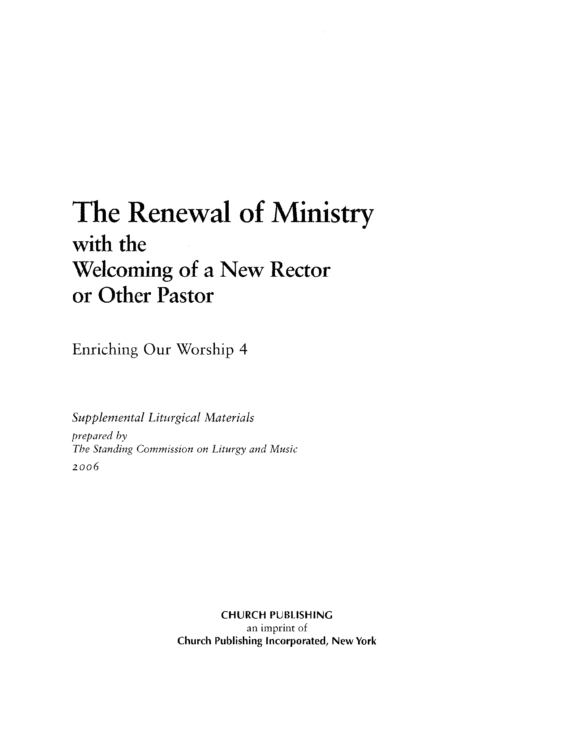 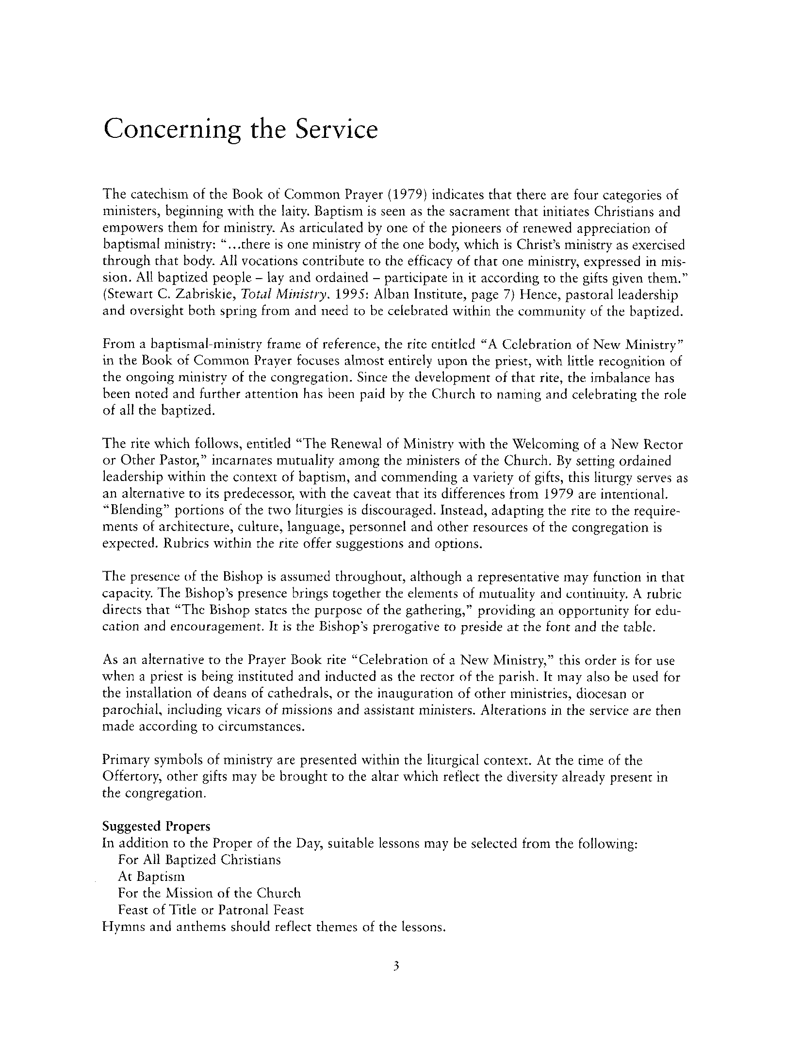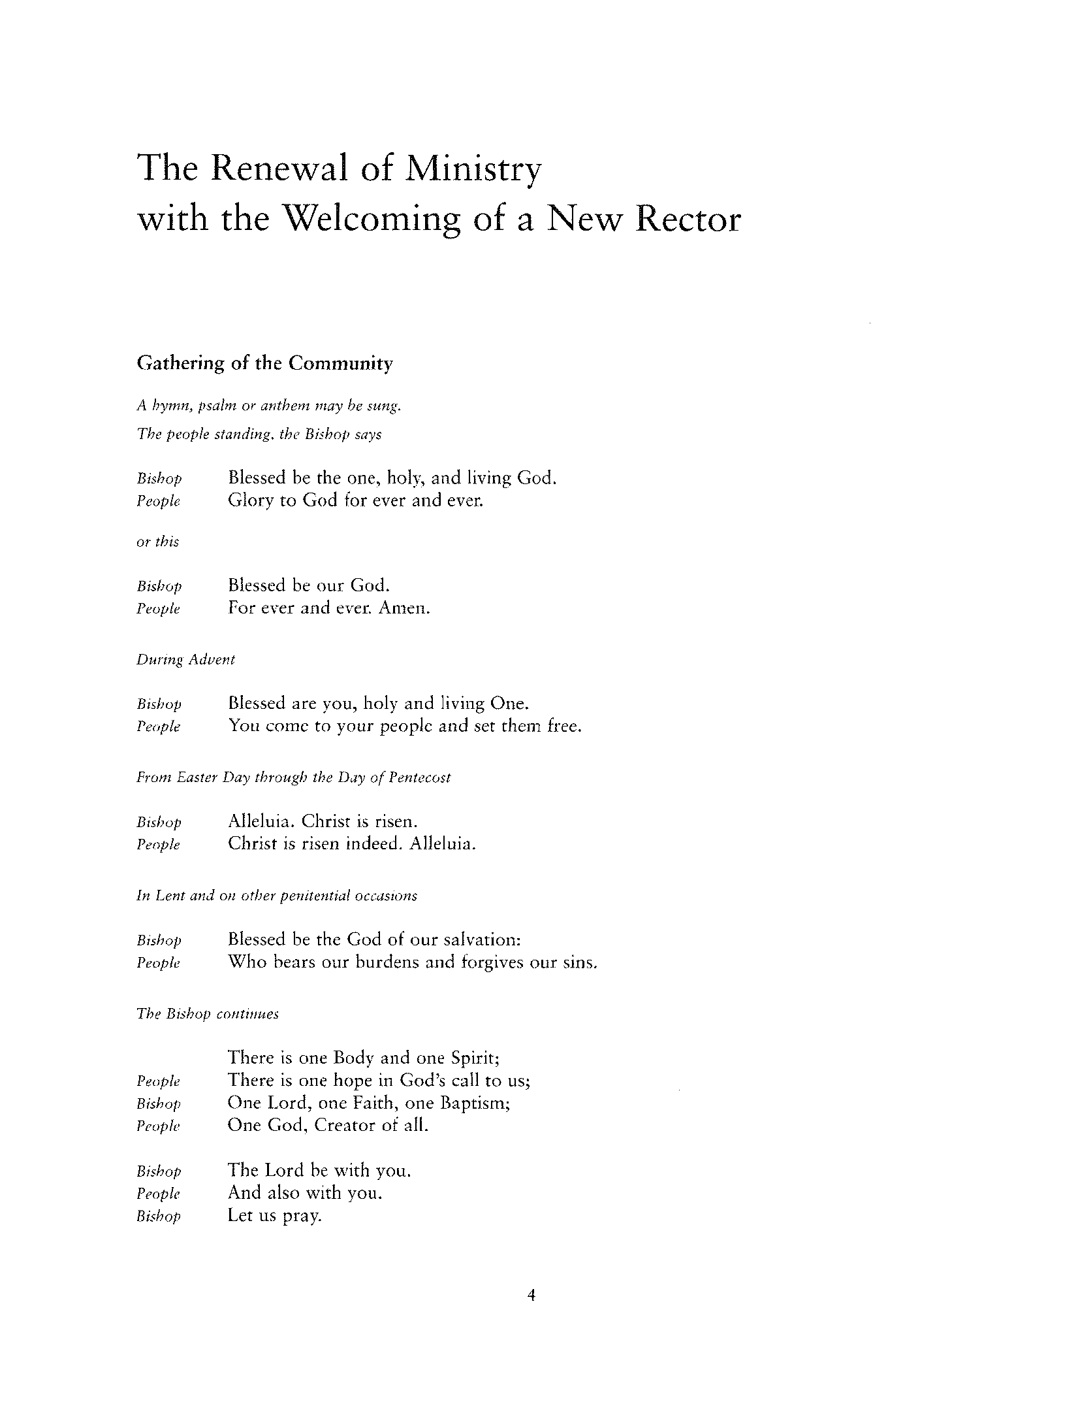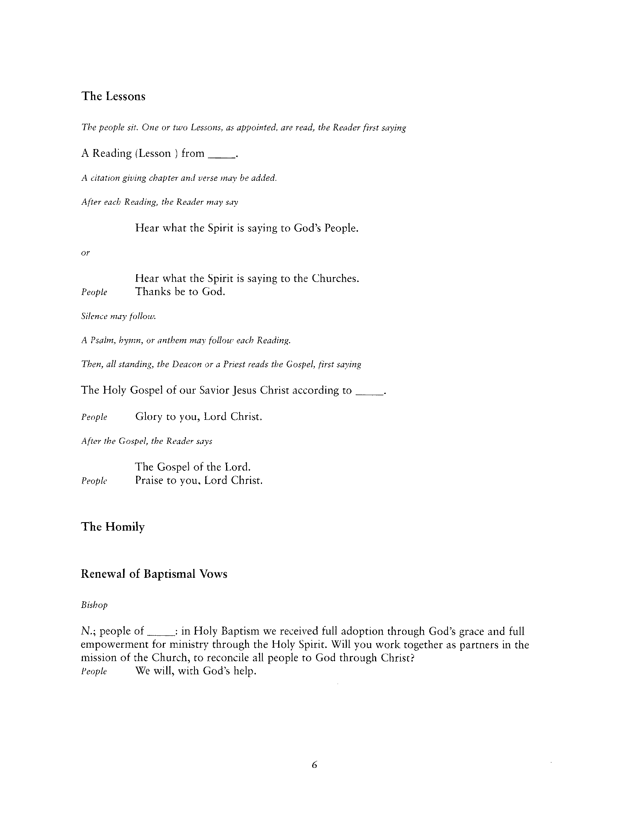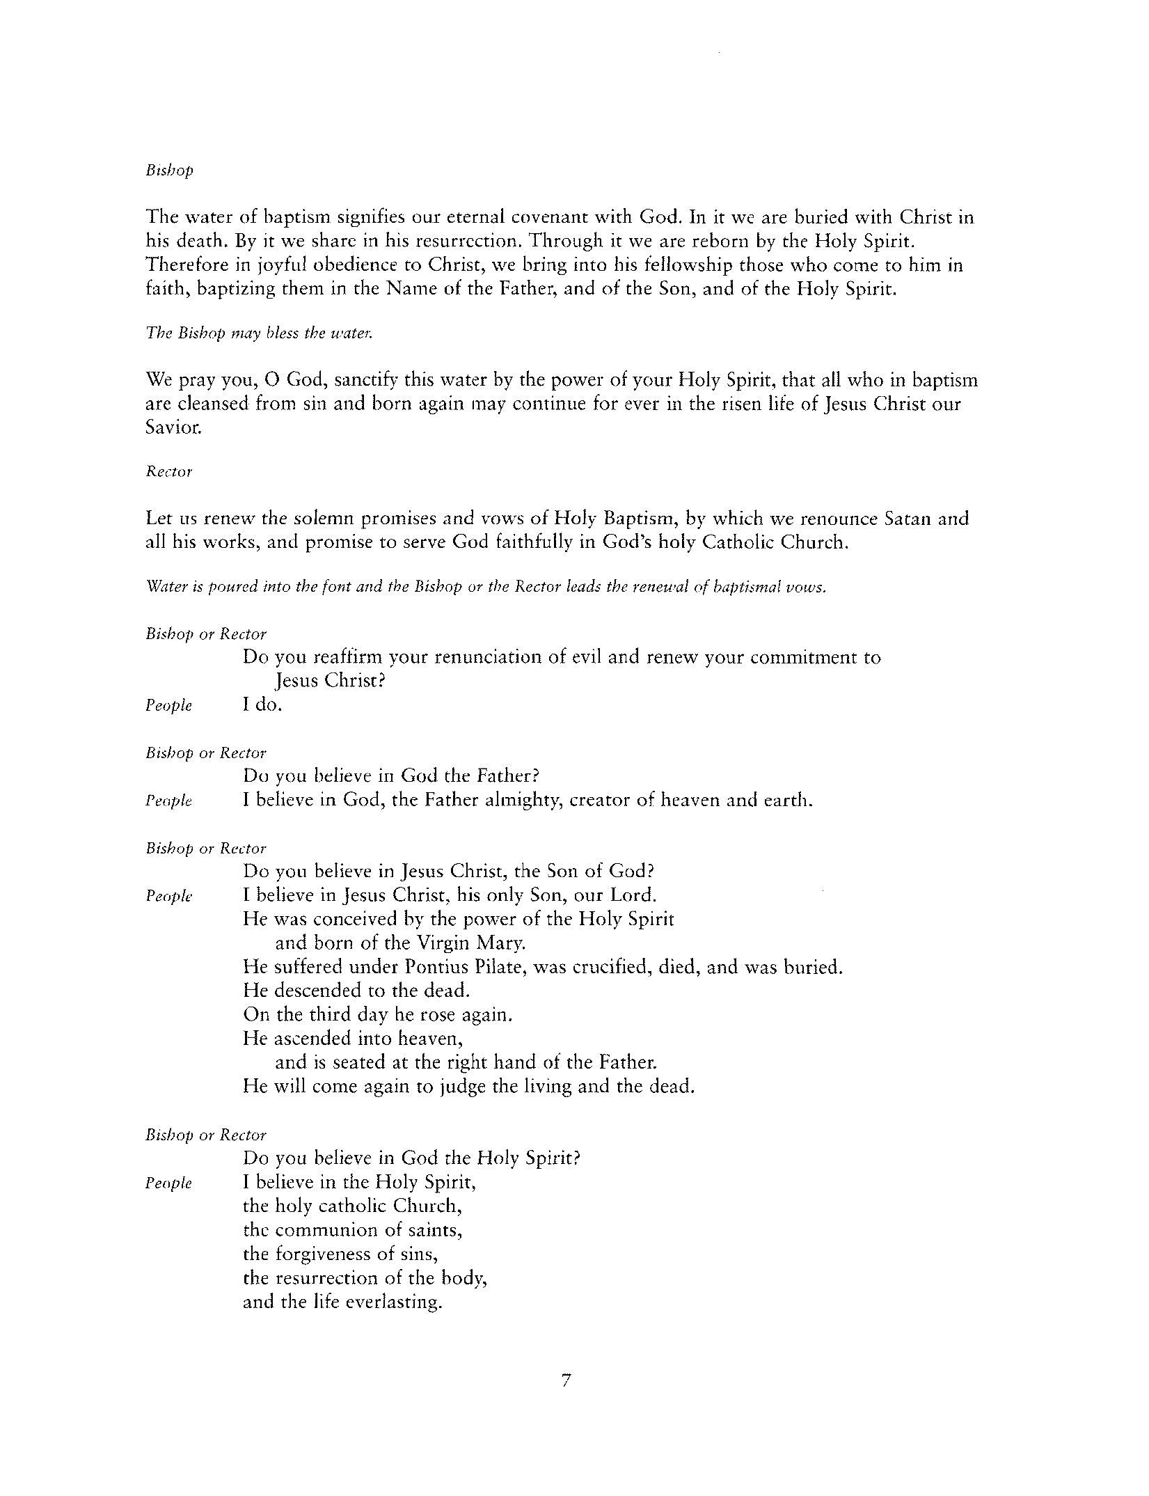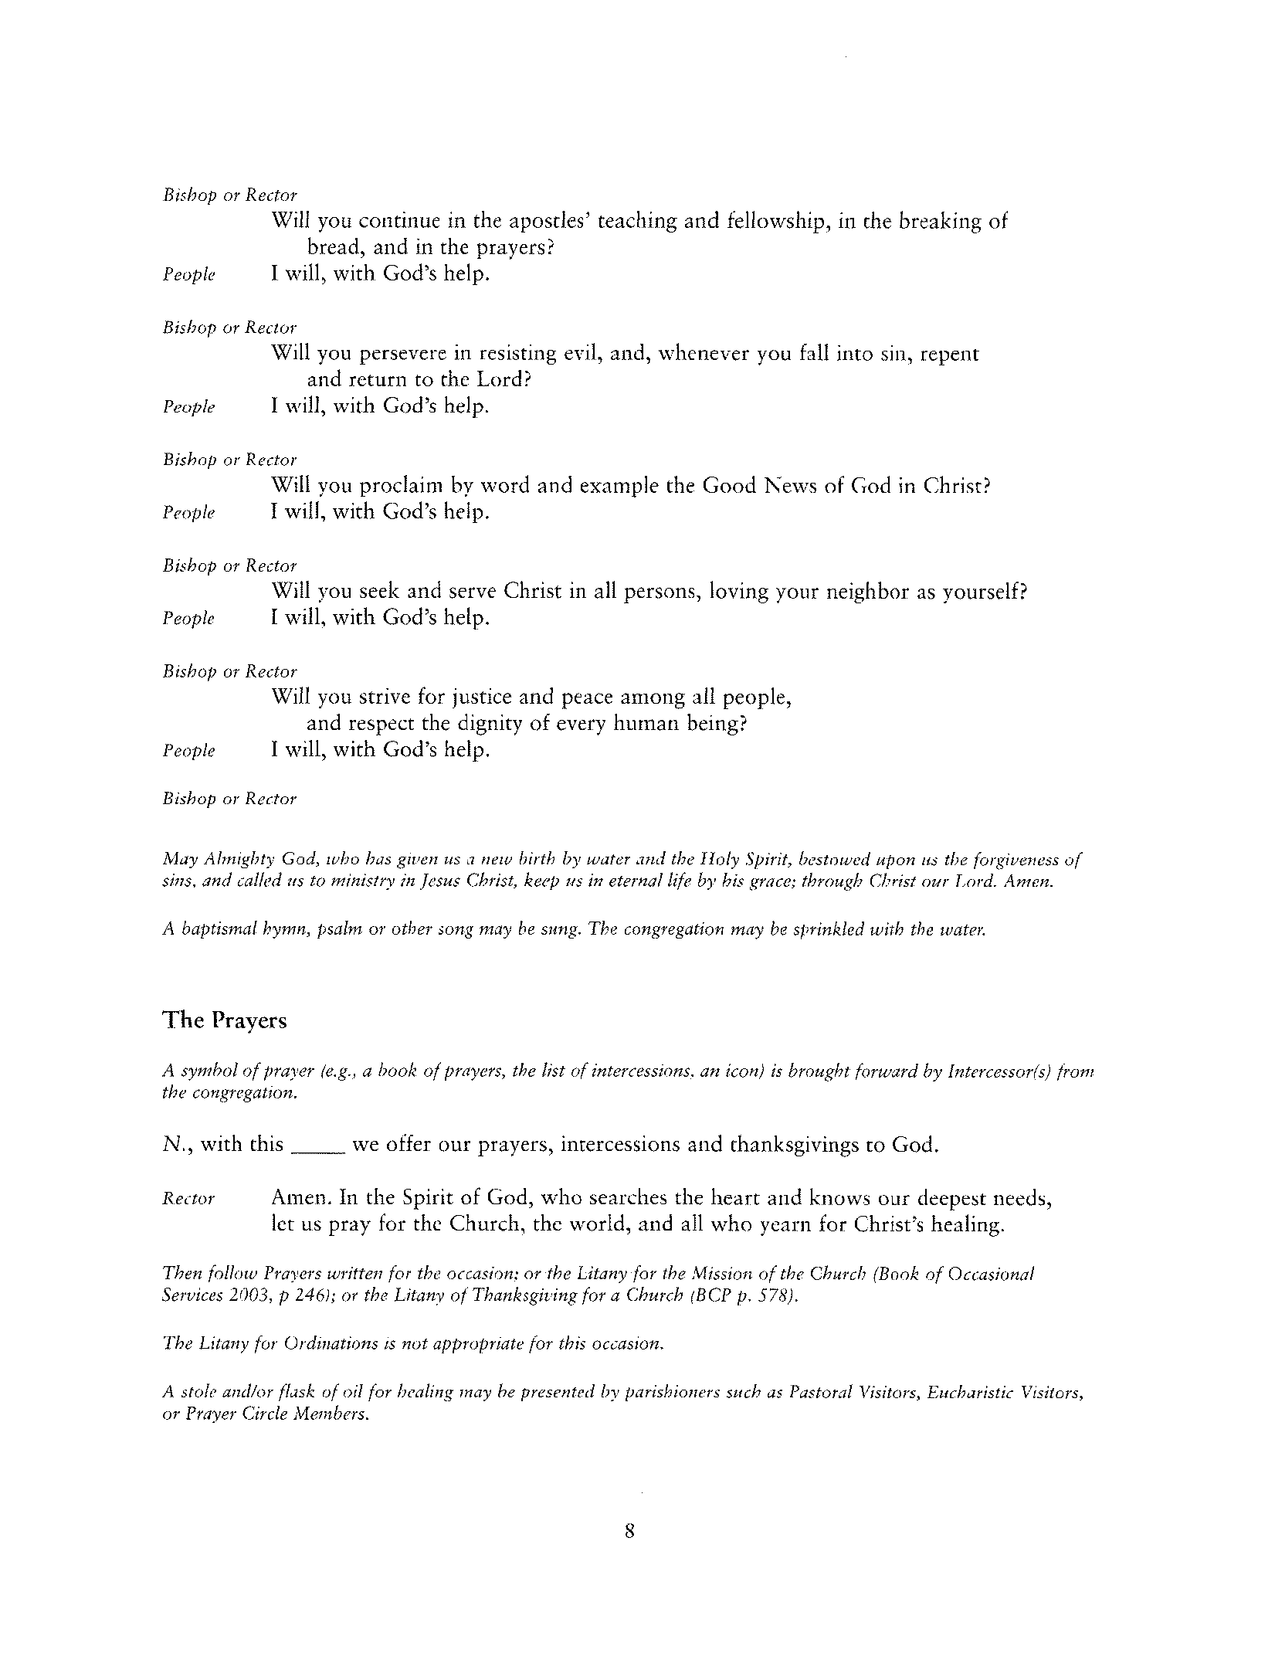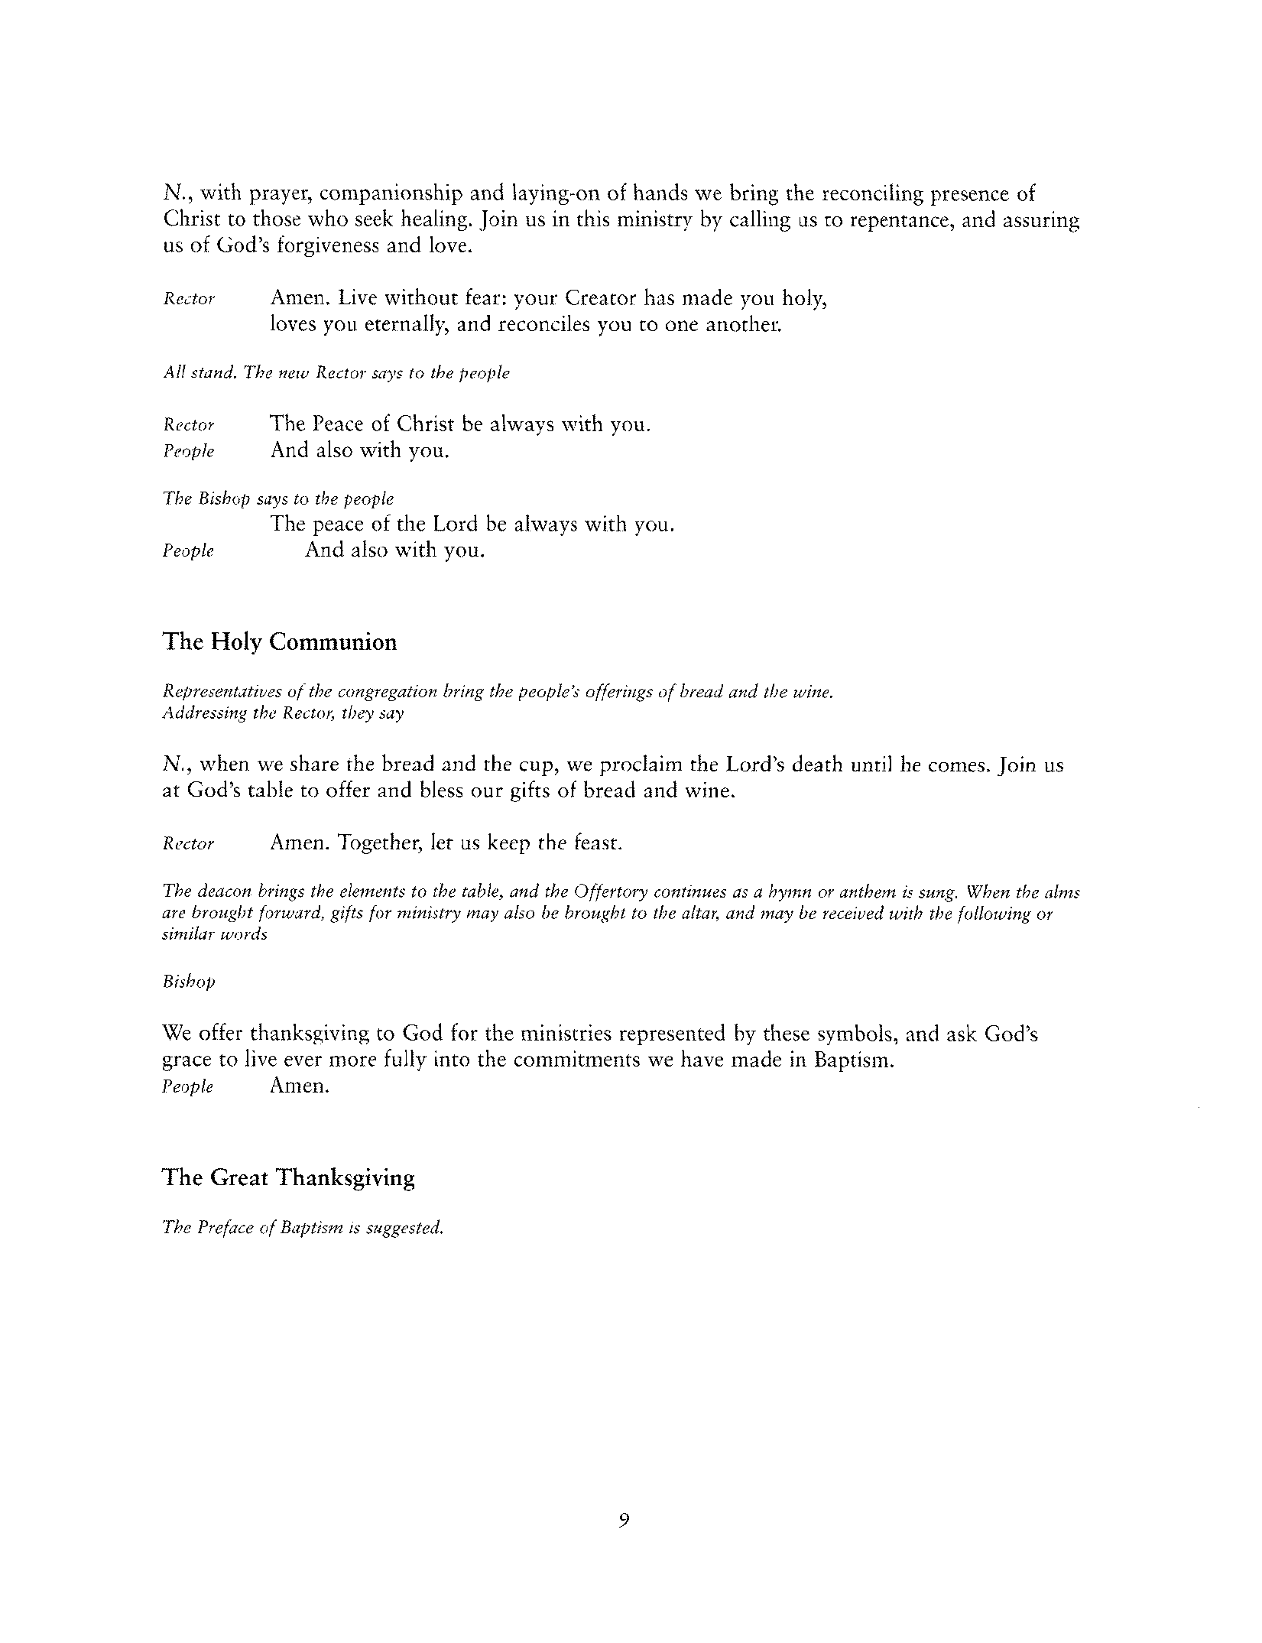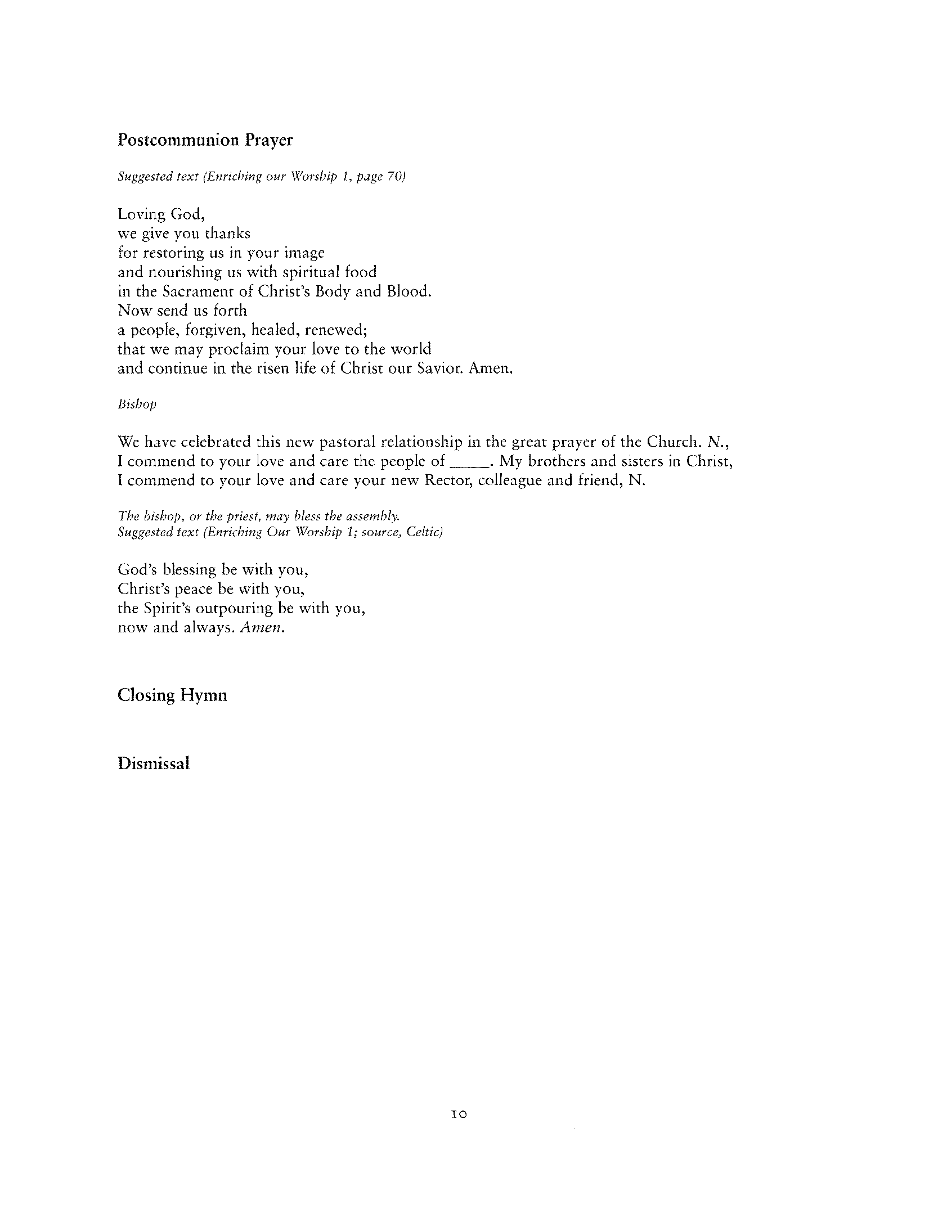

Copyright © 2011 CREDO Institute, Inc., et. al. All rights reserved.
Copyright © 2011 CREDO Institute, Inc., et. al. All rights reserved.

